1.Confirmation message not display while click the approve button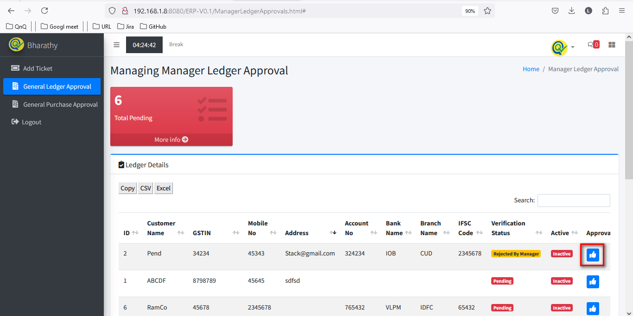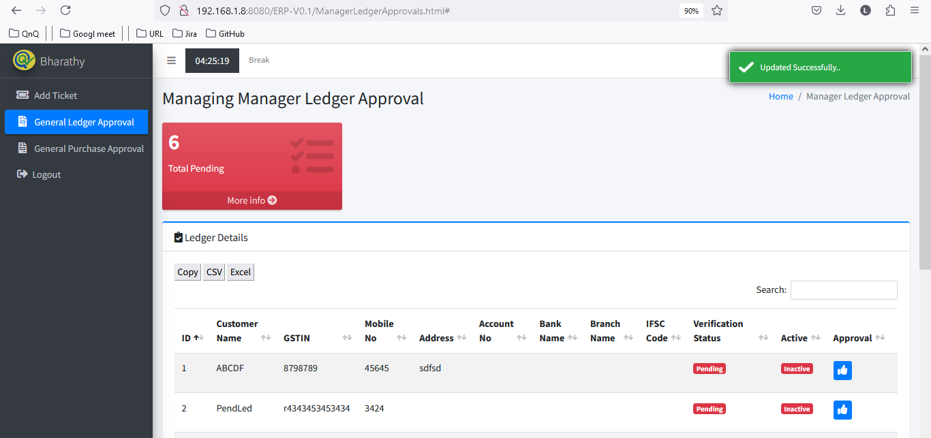

//

2. Mismatch name display for Menu and Page title 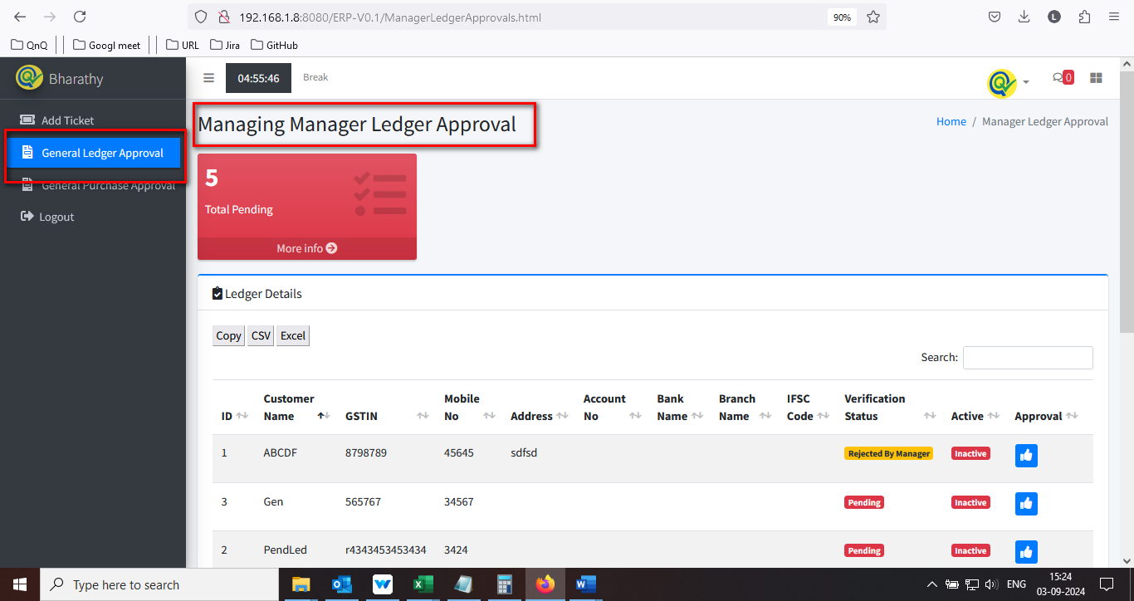

//

3. Mismatch column header name display 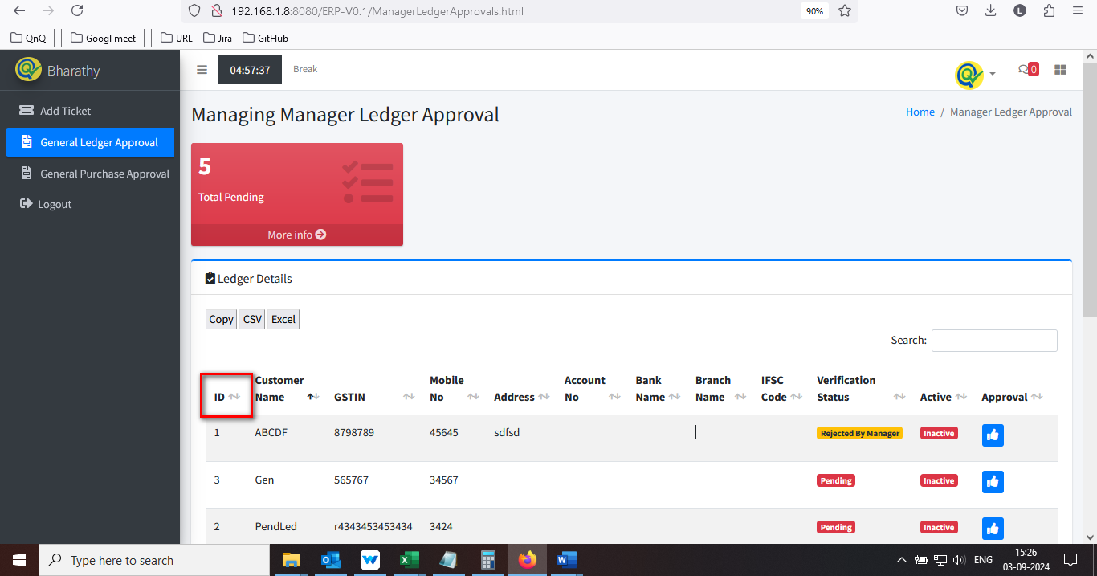

//

4. Placeholder or inner text not display in Search filter text box 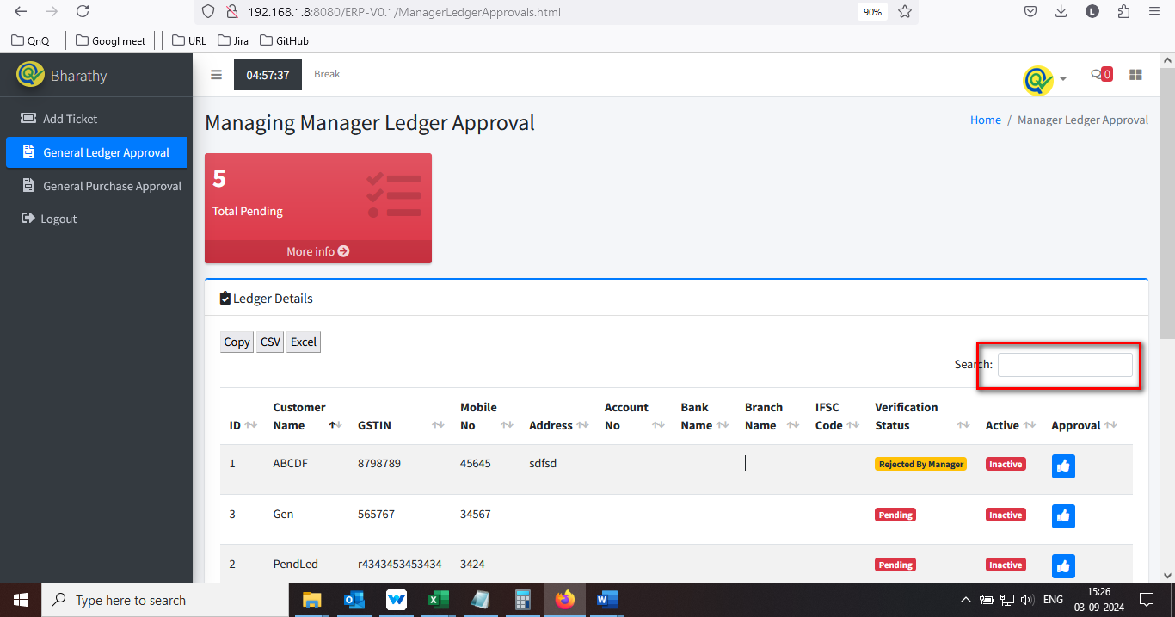

//

5. Icon's not display in download option section 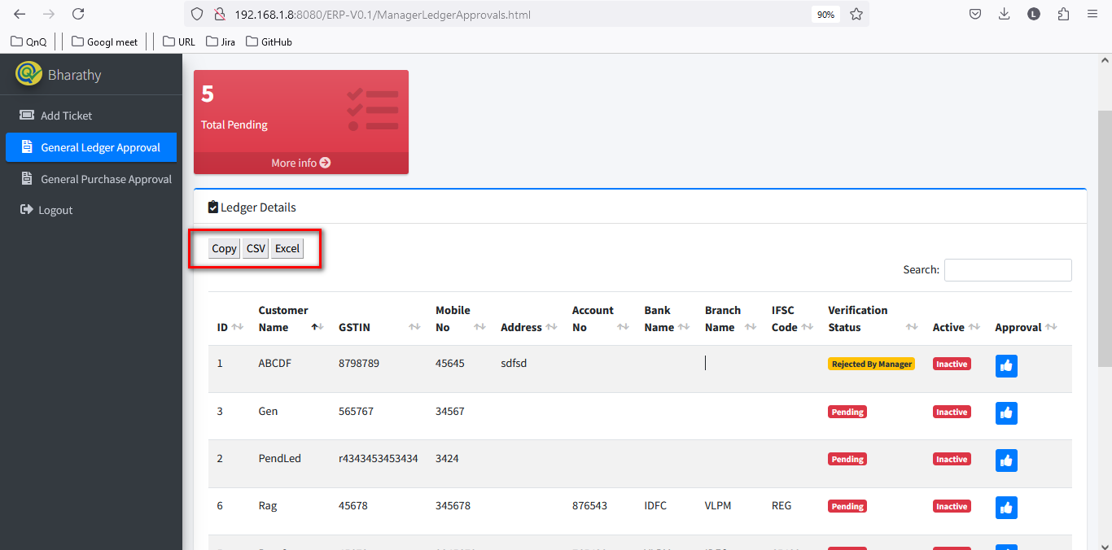

//

6. List grid display Improper border alignment 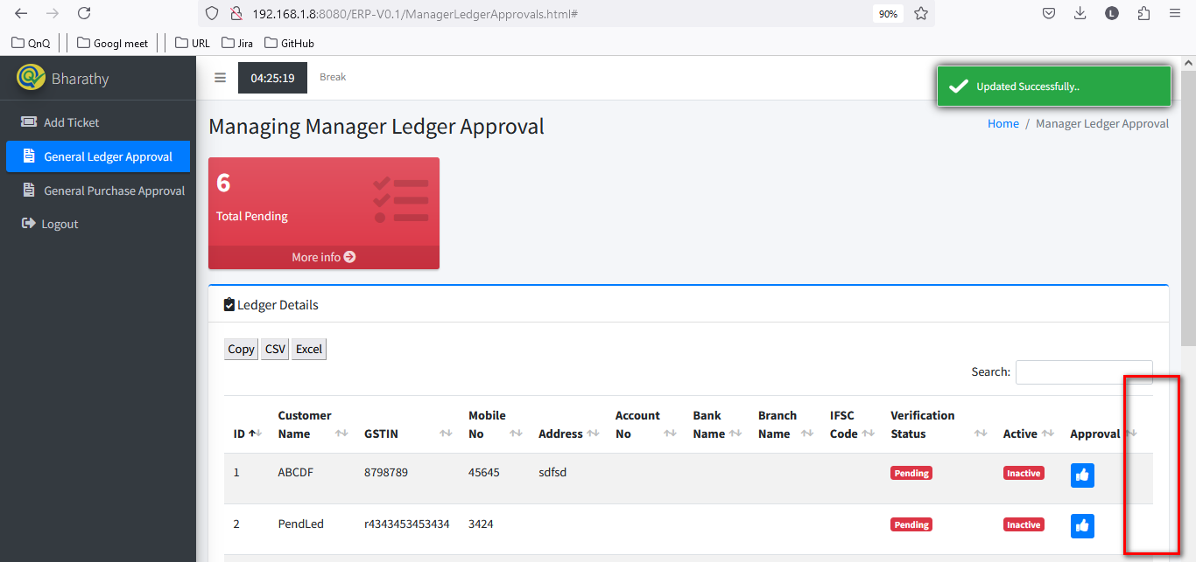 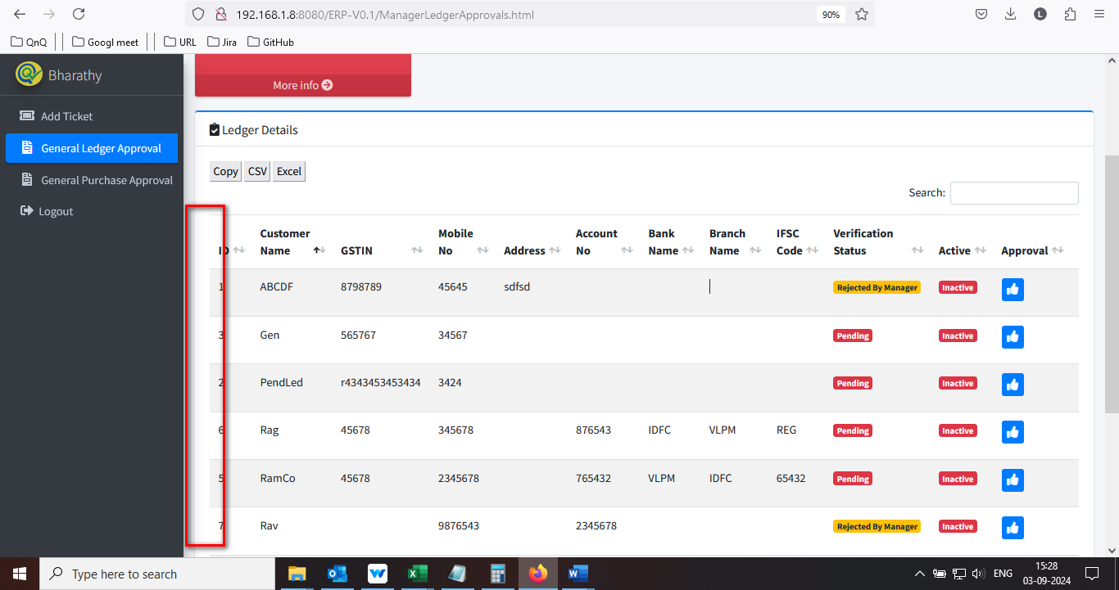

//

7. Unwanted column display in Item list grid 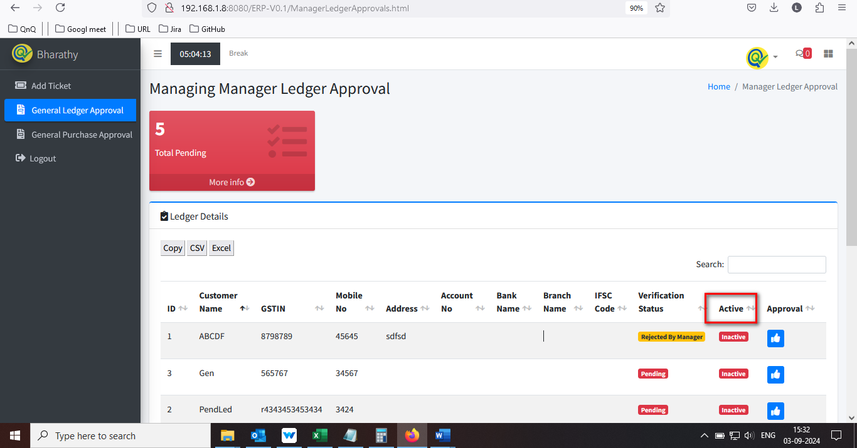

//

8. Icon’s not display in middle of the column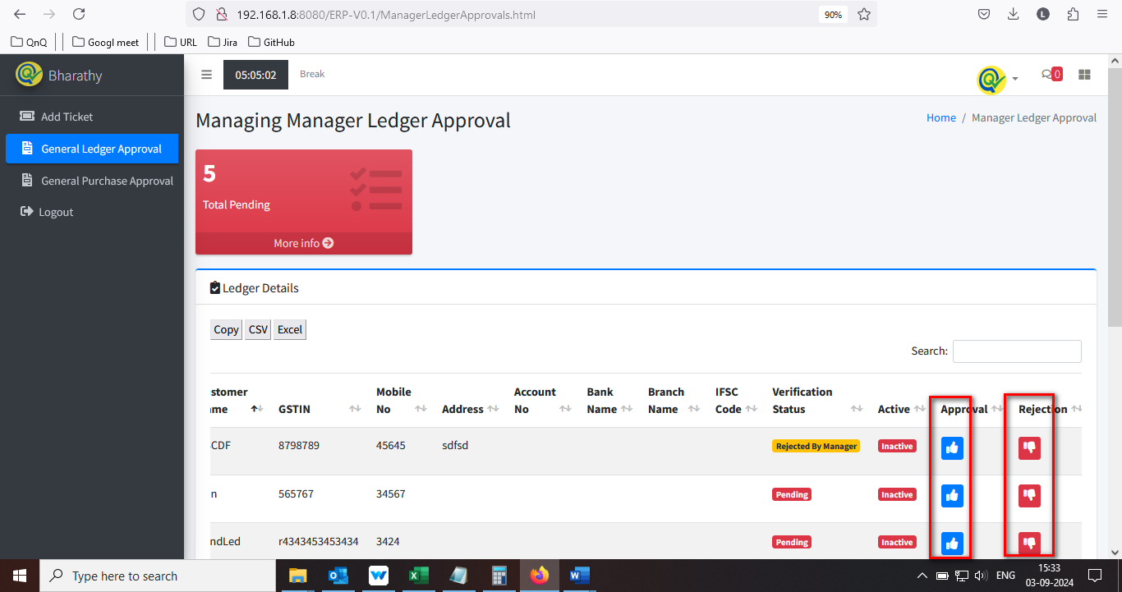

//

9. Column separator highlighted line not display in list grid 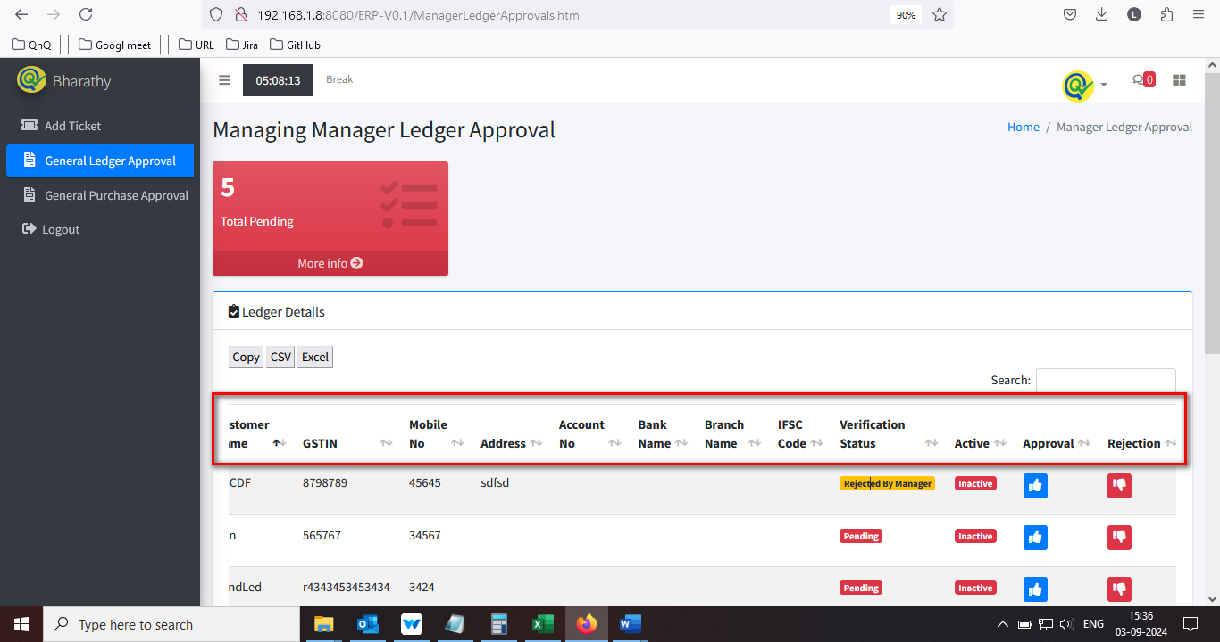

//

10. Sort icon display as too small 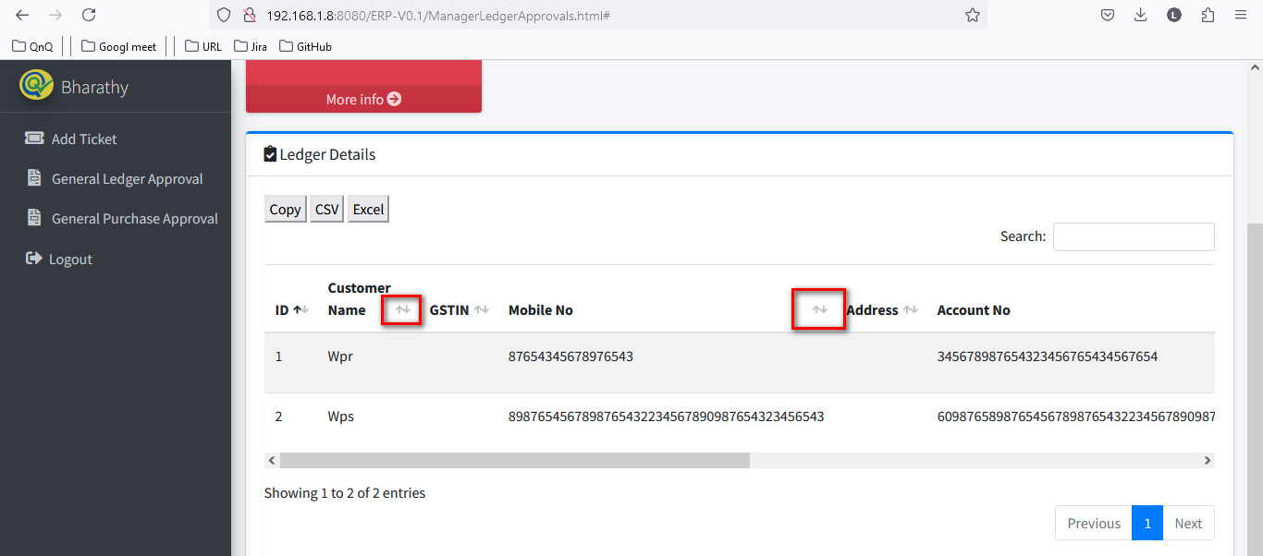

//

11. More info button not working

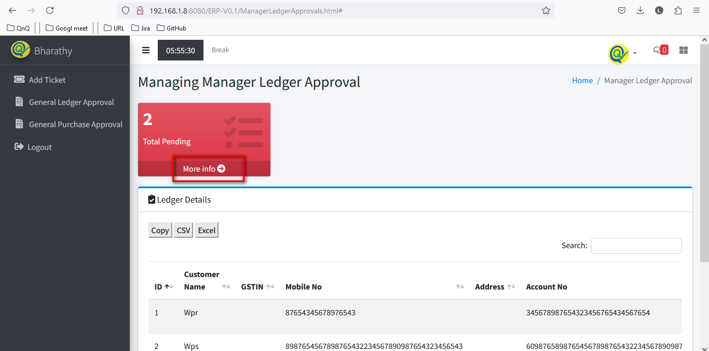

//

12. Sorted highlighted display in list grid when there is no data available in list grid 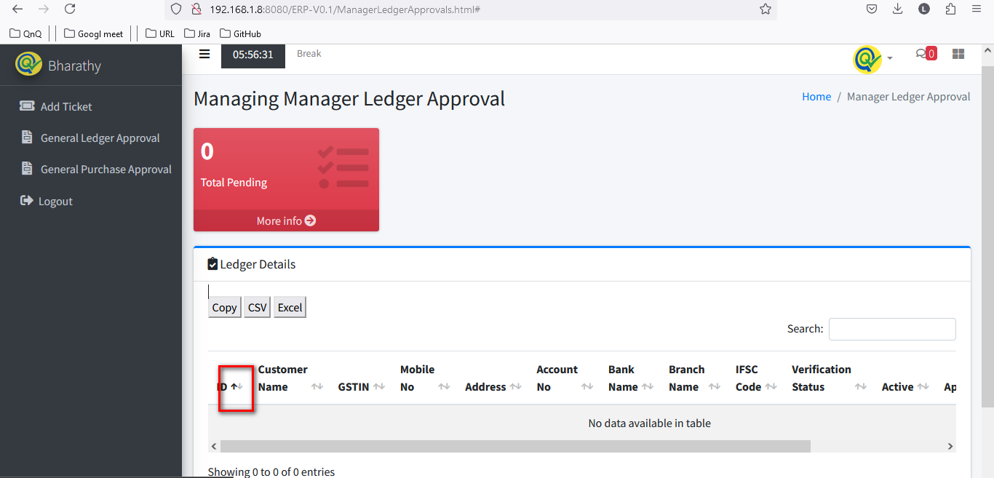

//

13. Improper alignment display in list grid while maximum value 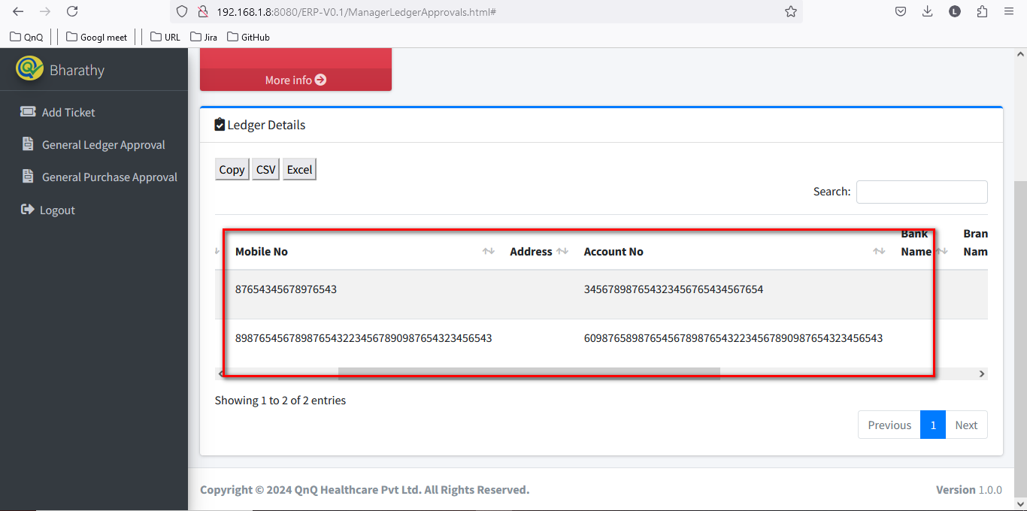

//

14. Duplicate record display in Ledger Approve list grid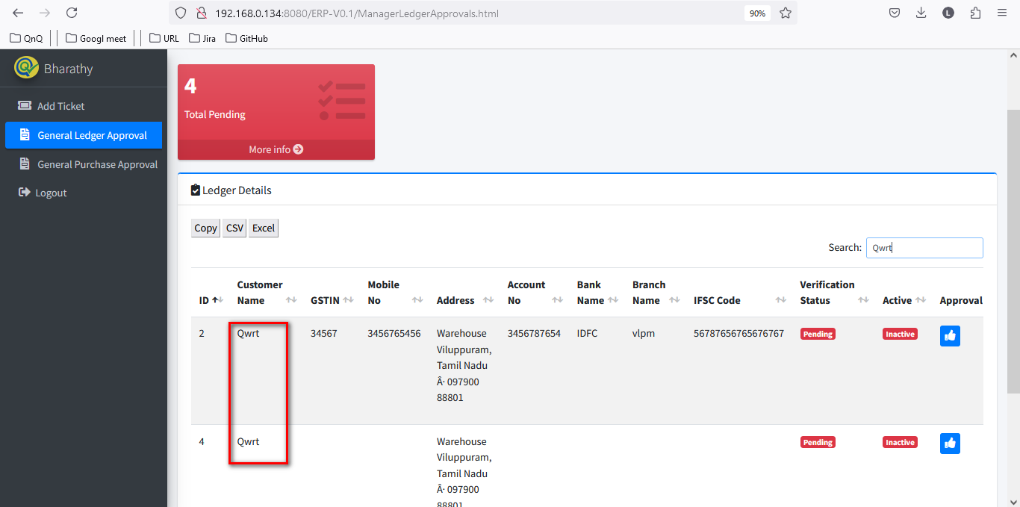

//

15. Required error message not getting display while skip/click the submit button 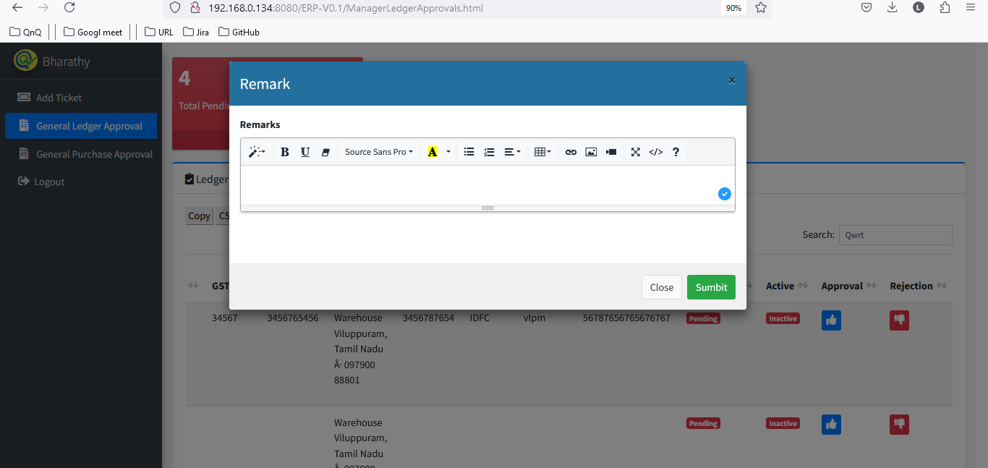

//

16. Values display in remarks fields while click Reject icon 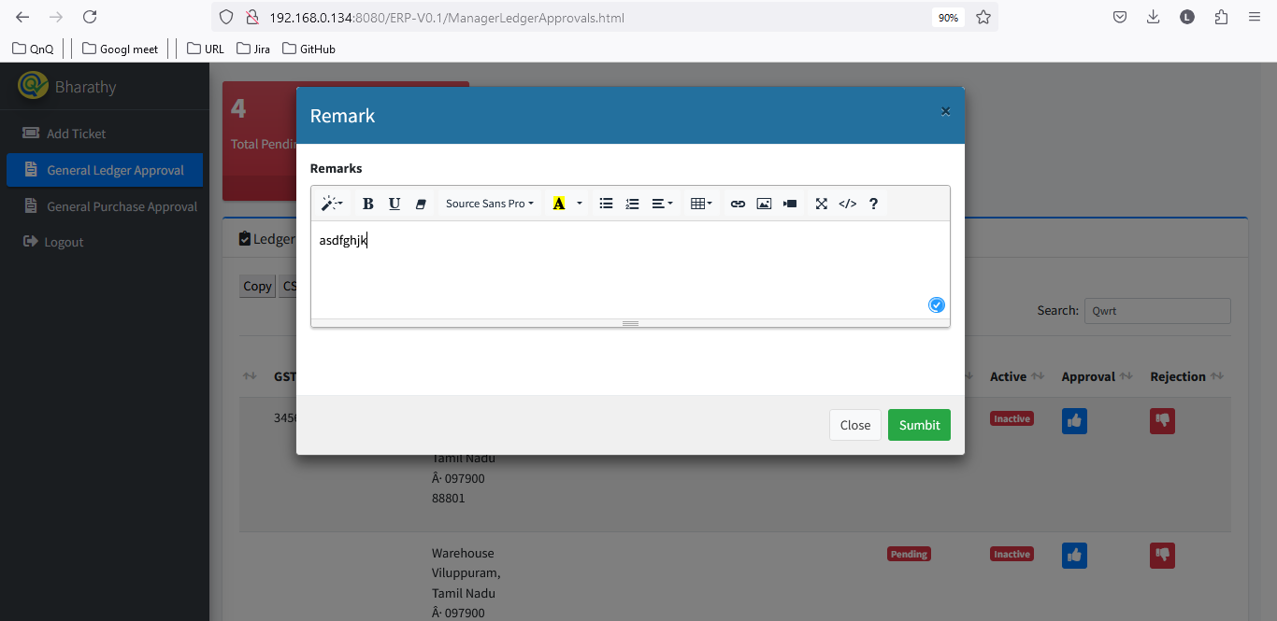 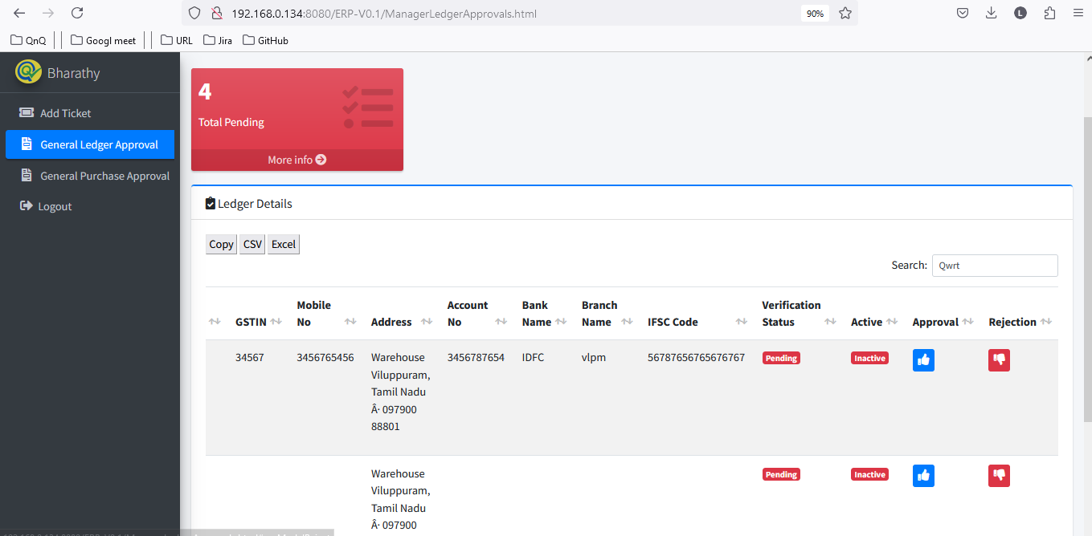 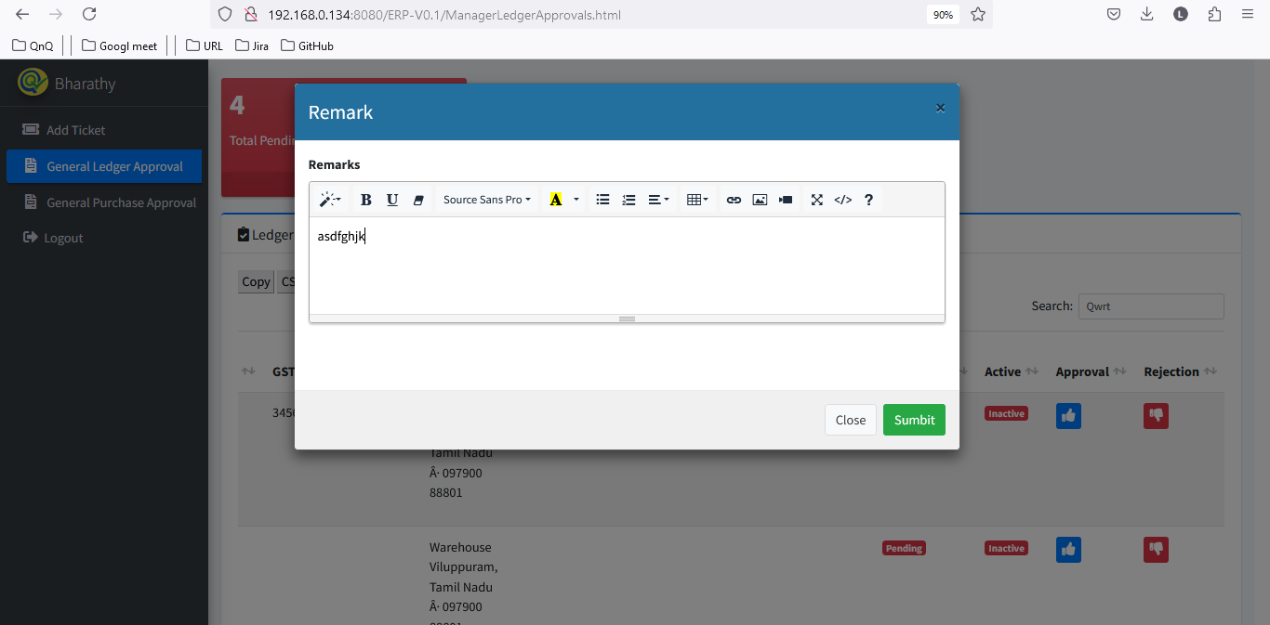

//

17. Mismatch pop up title display 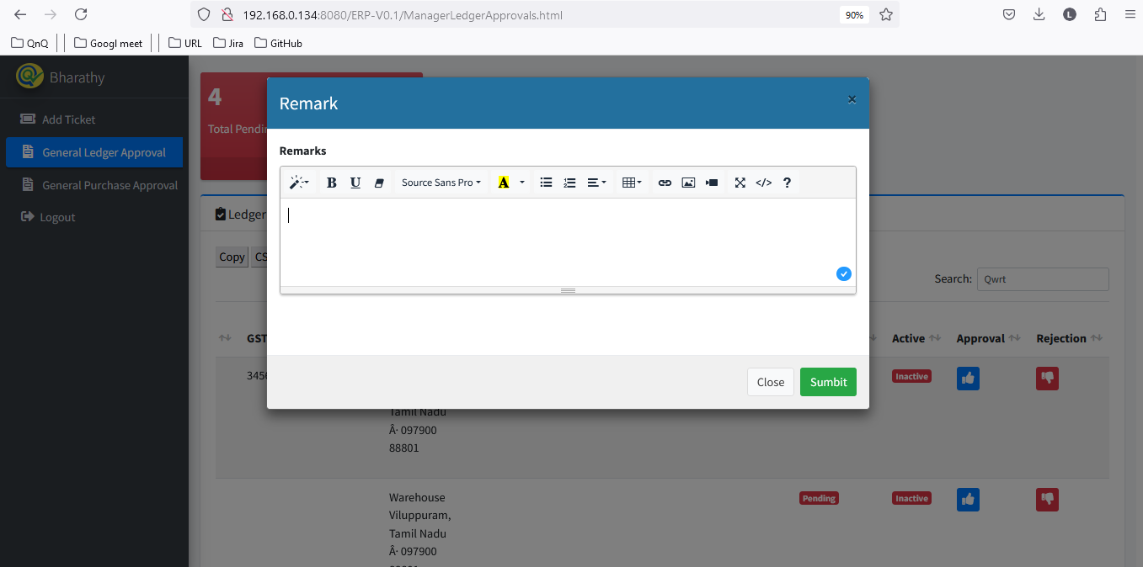

//

18. Close icon not display properly 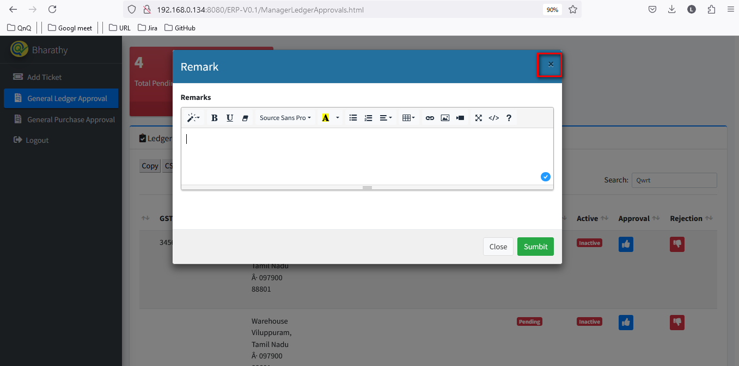

//

19. Confirmation message not display while close the pop up with all values 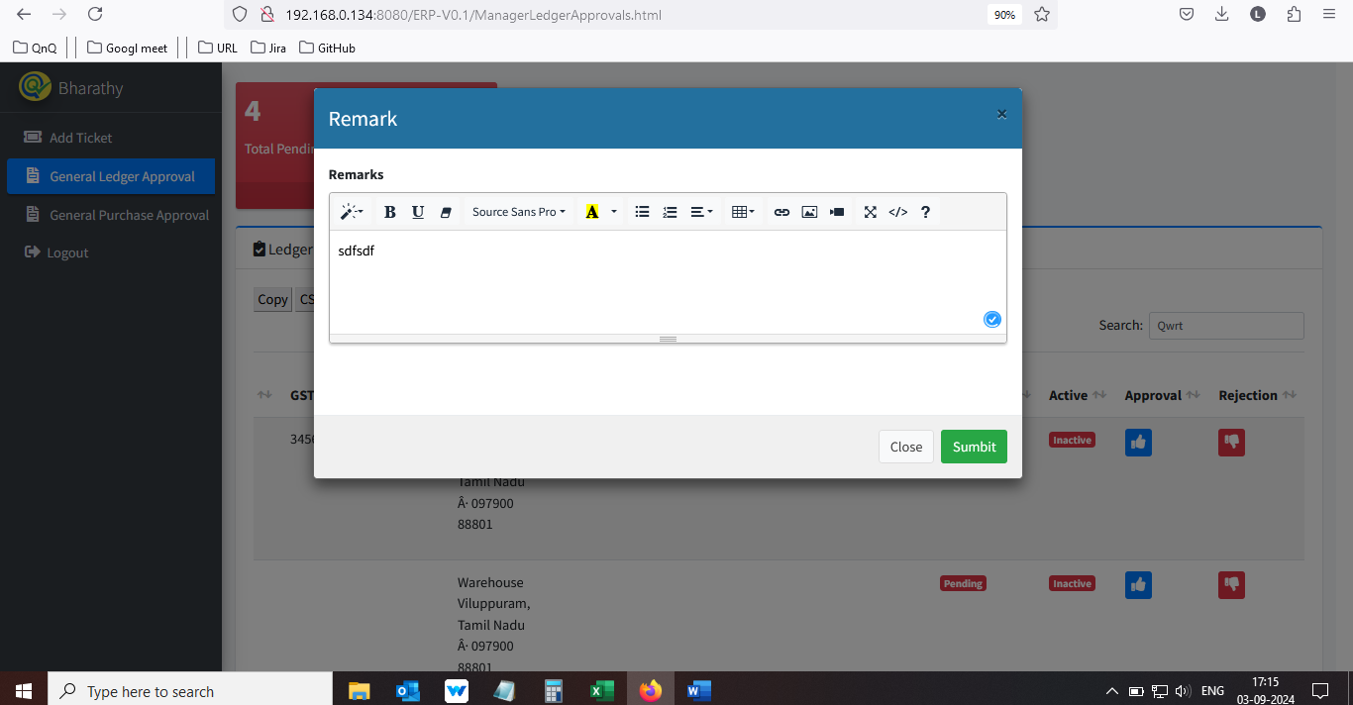 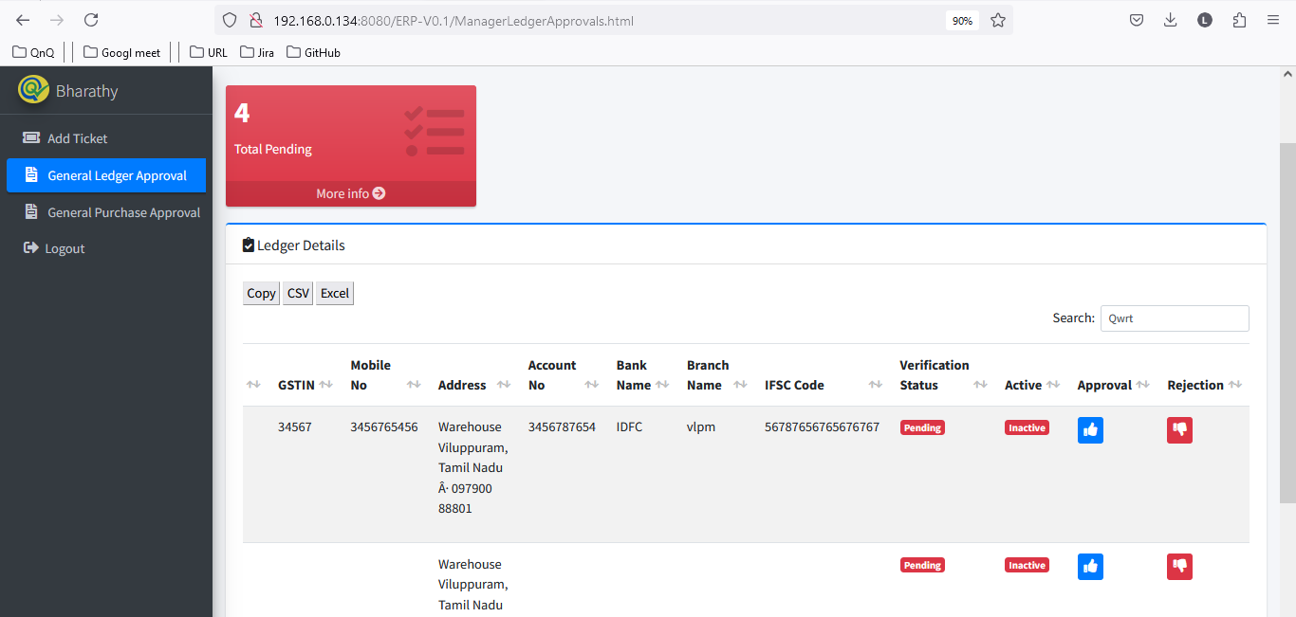

//

20. Rejection up getting close while click beyond the pop up  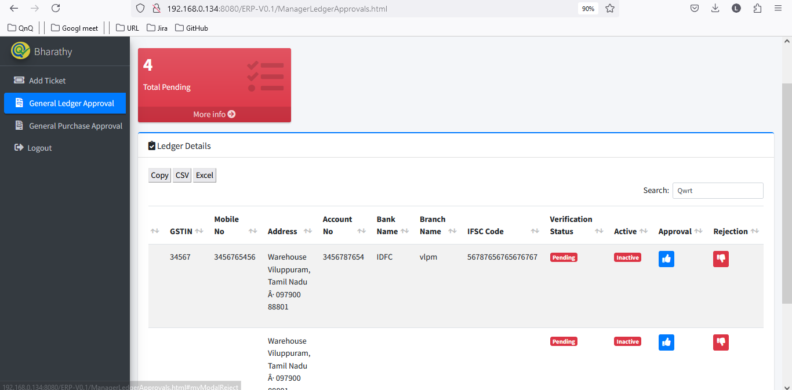

//

21. Remarks field display resized alignment, while click the add new button 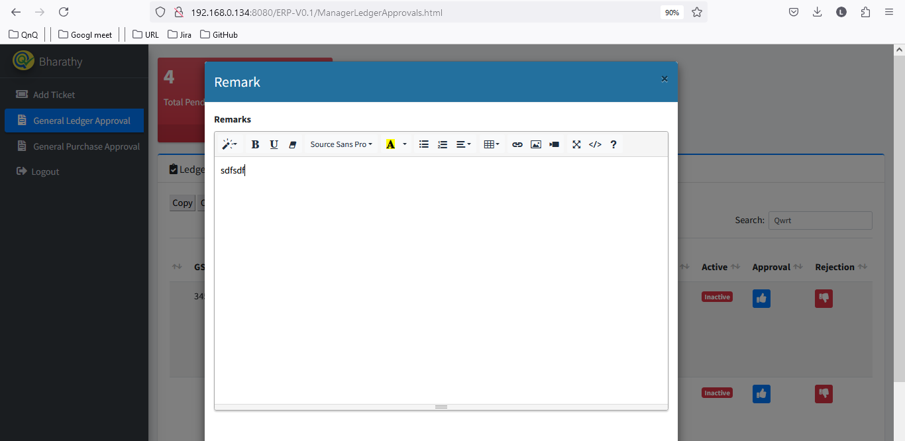 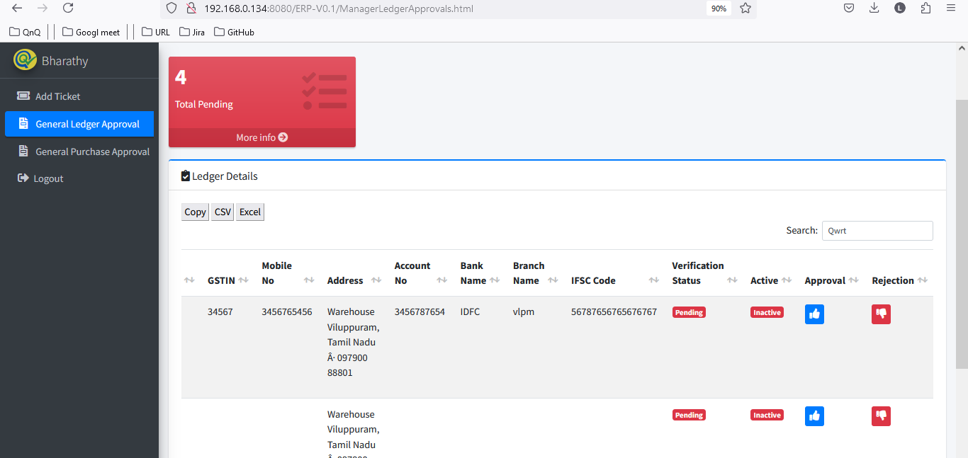 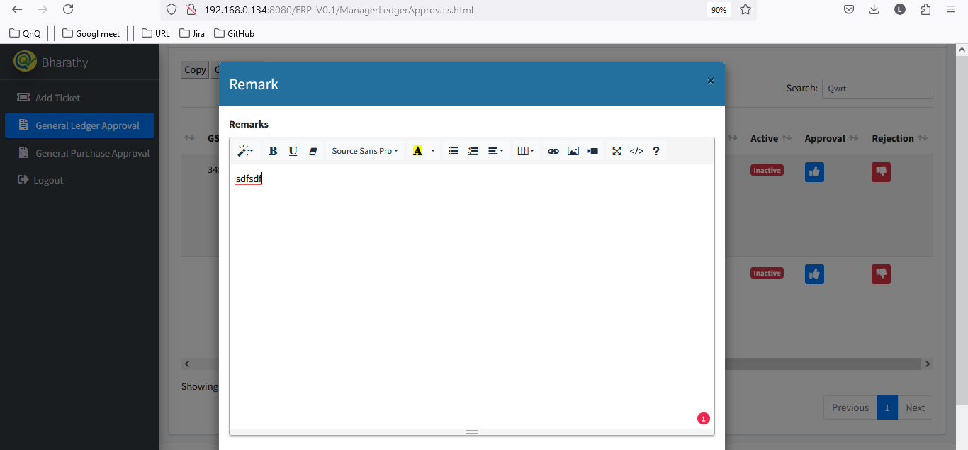

//

22. Tool tip not display for Close icon 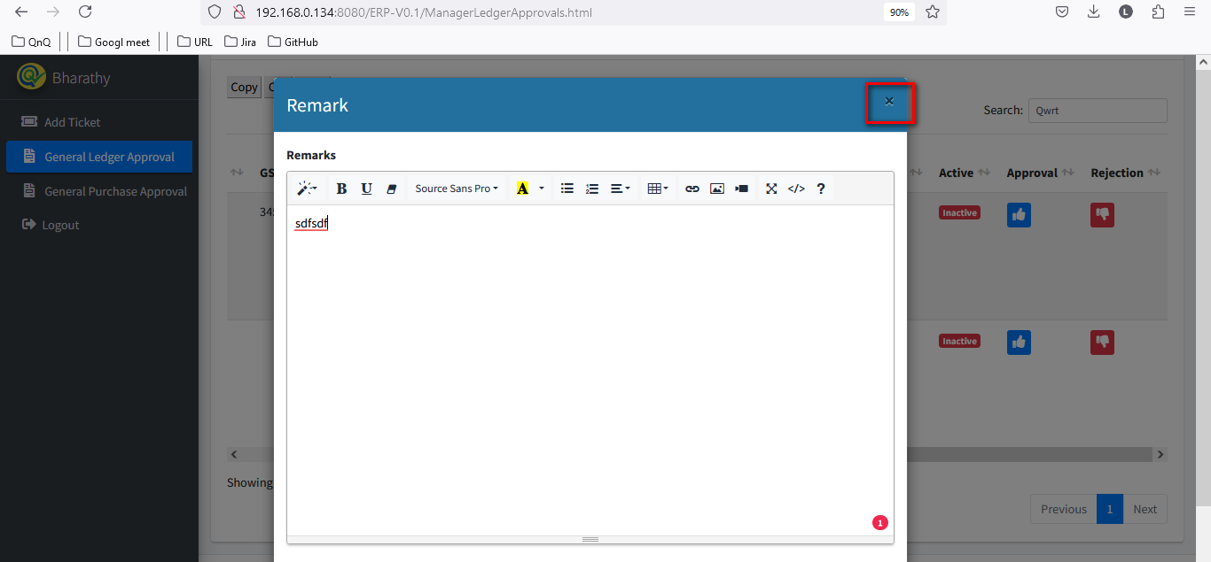

//

23. Placeholder or inner text not display in Remarks field 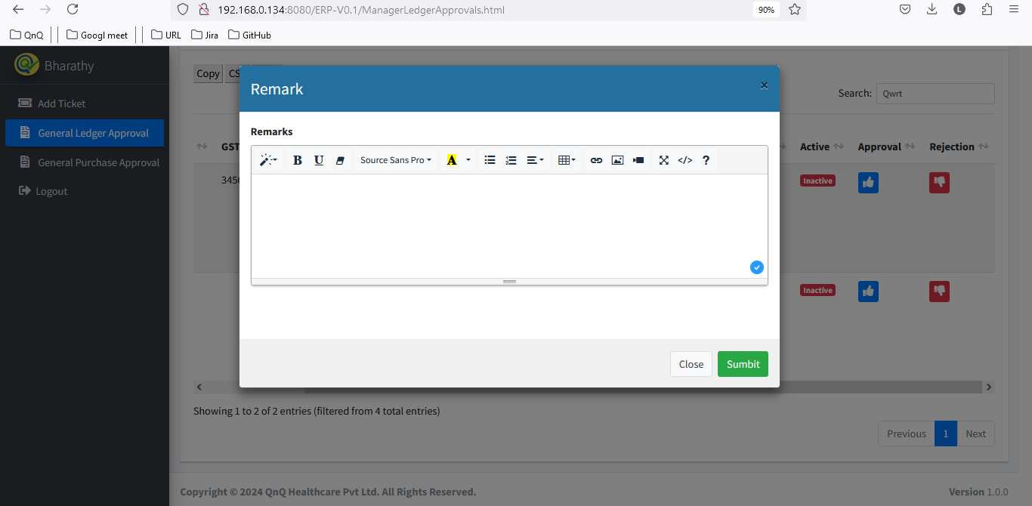

//

24. Error message display while click submit button with insert image in remarks field 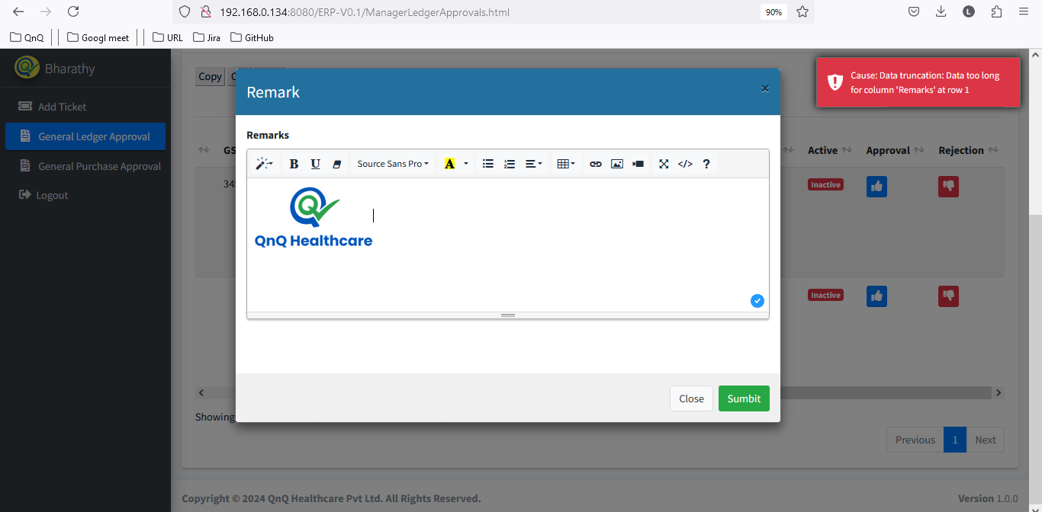

//

25. UI getting collapse while click code view button 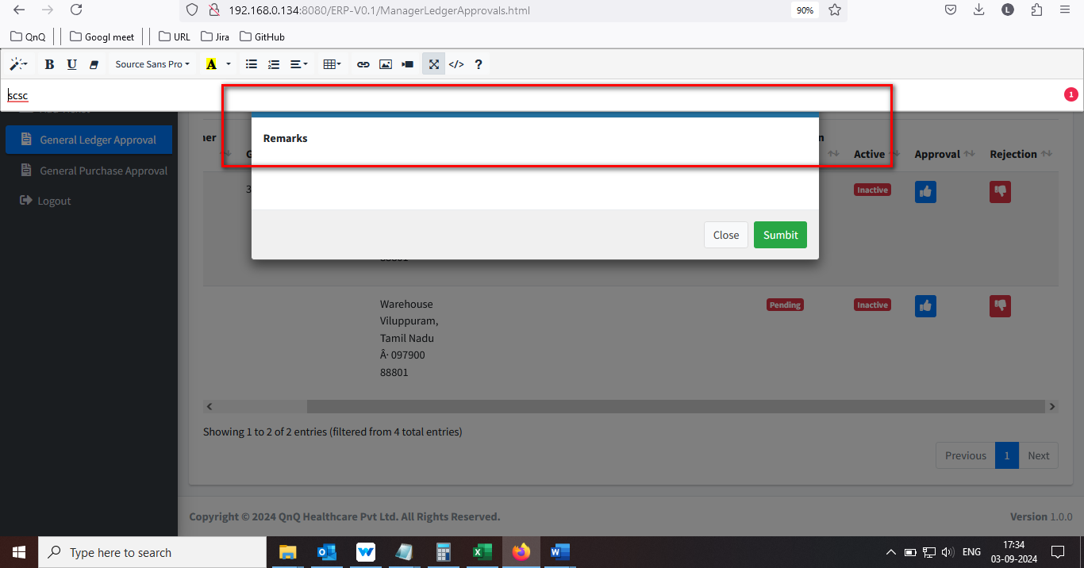

//

26. Reject pop up getting close while close the Video/Image/Link pop up 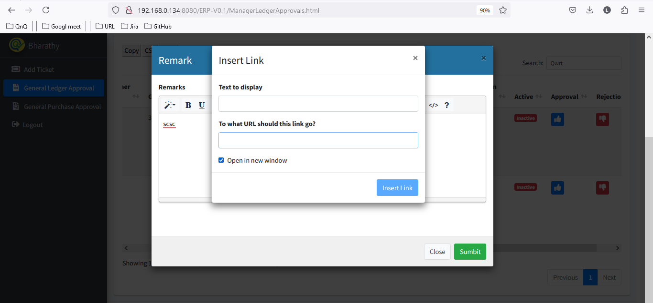 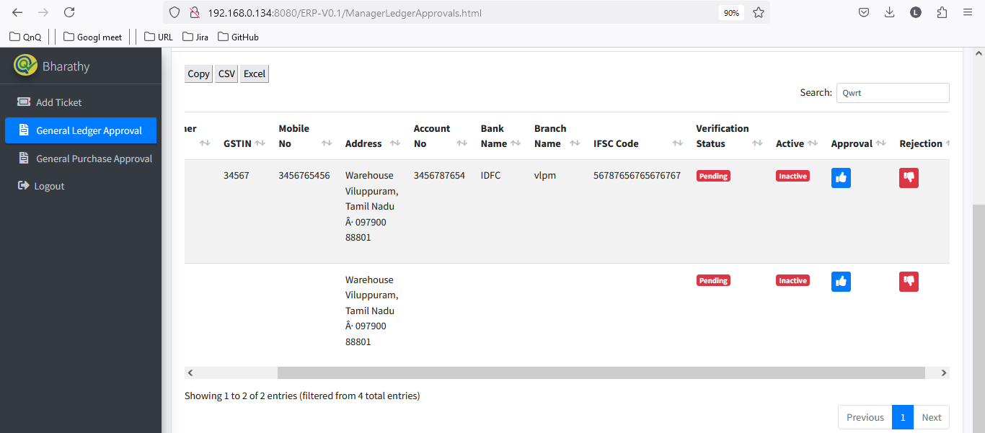

//

27. New URL not getting load same page when uncheck the open in new window 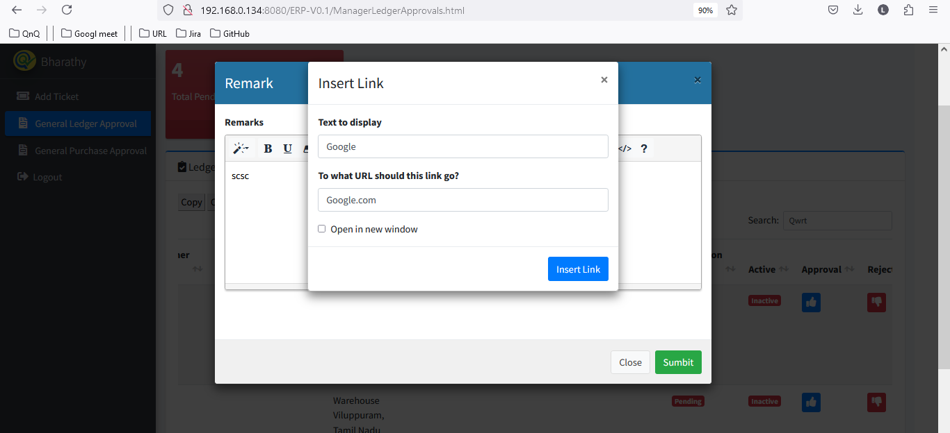 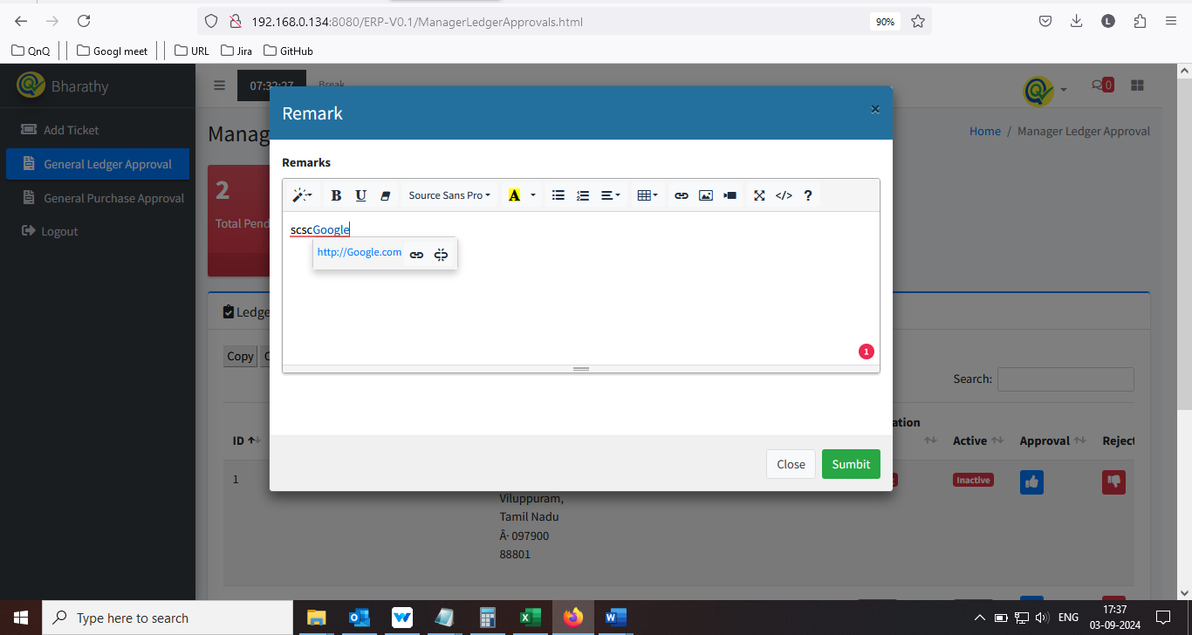 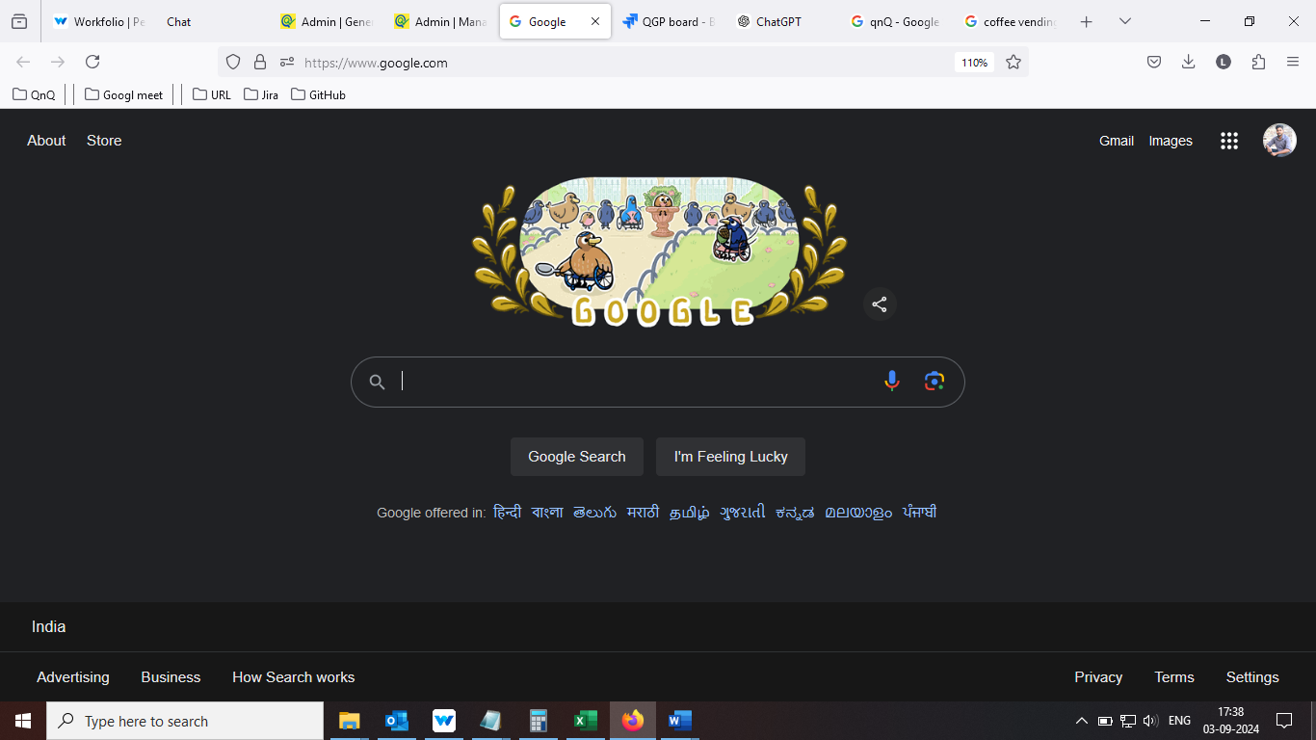

//

28. Given URL not getting clear while unlink the URL 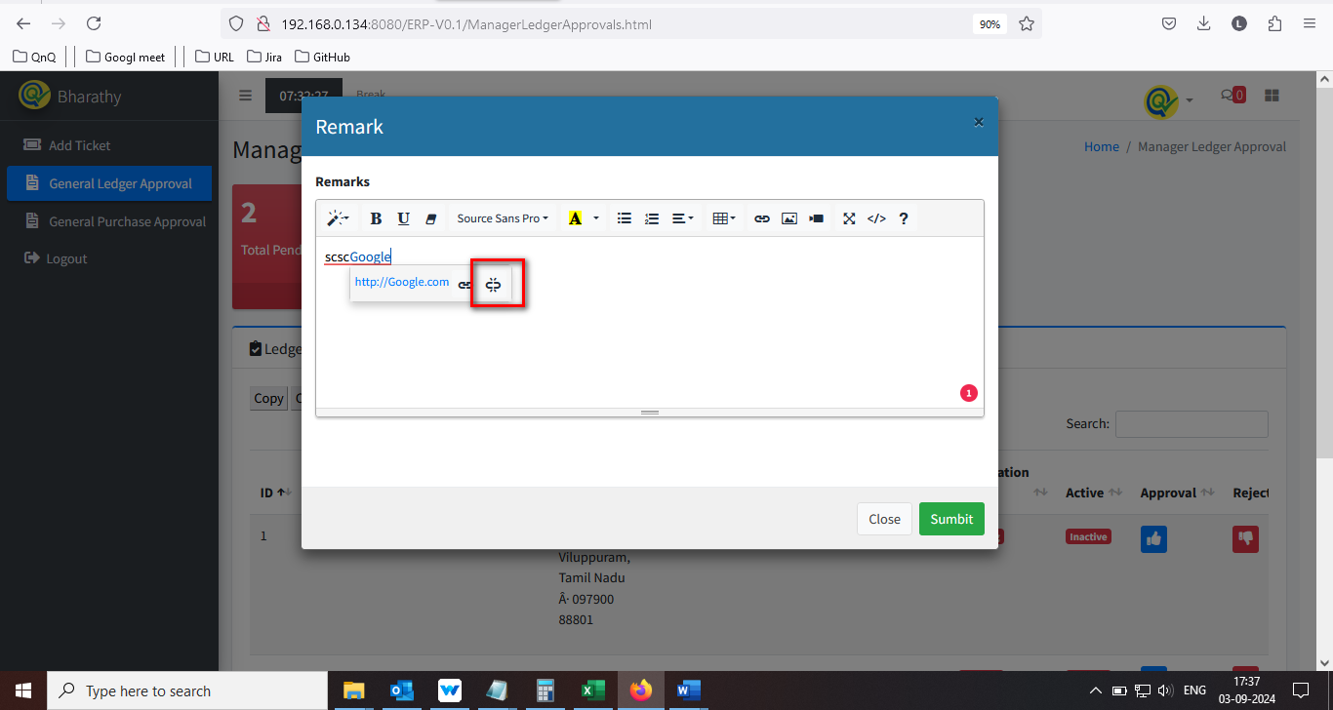  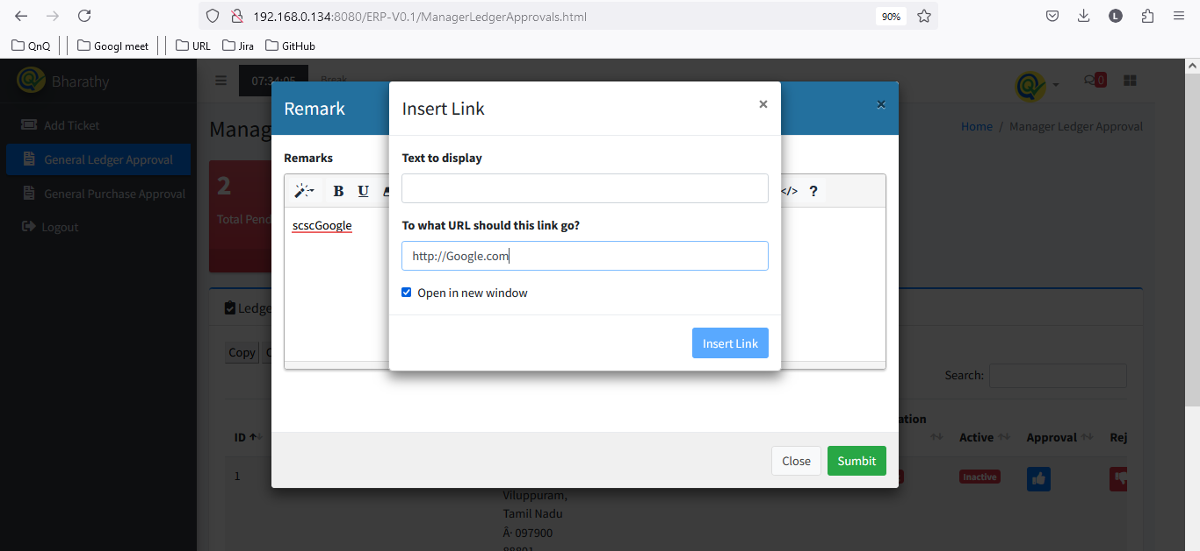

//

29. Video/Image/Link pop up getting close without click close icon 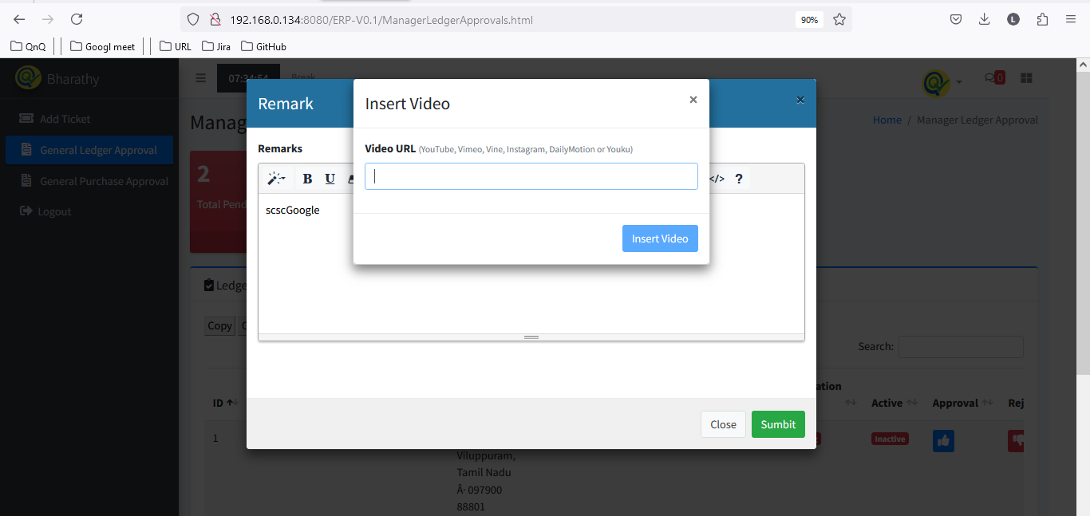 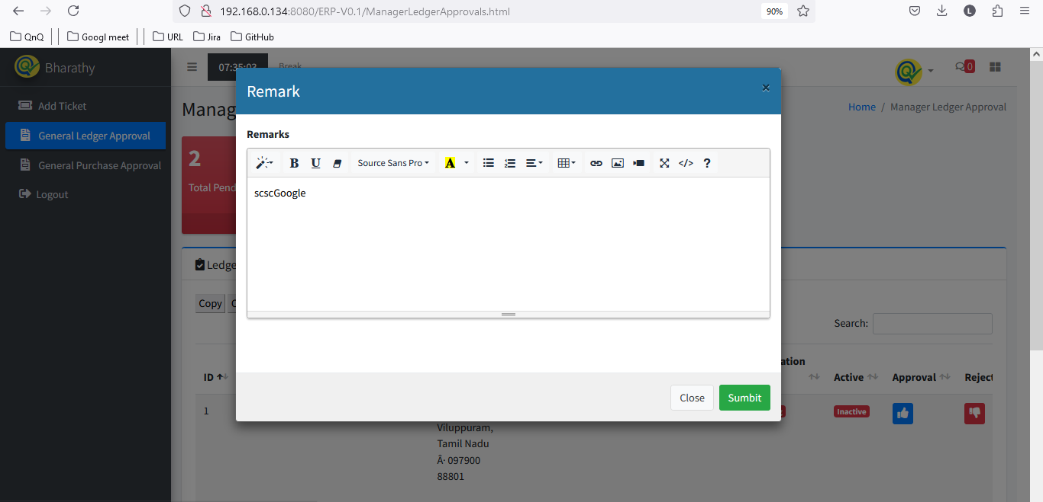

//

30. Given video link not display in Item Remarks field 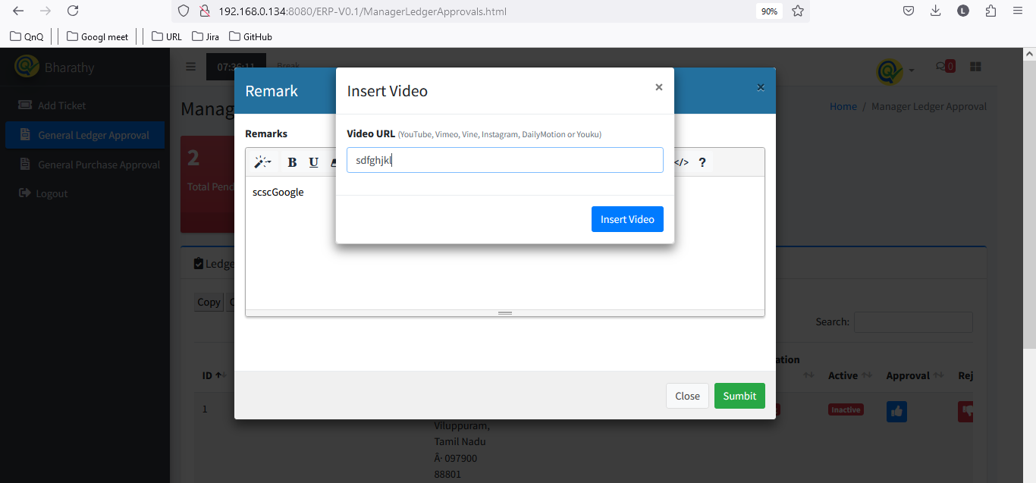 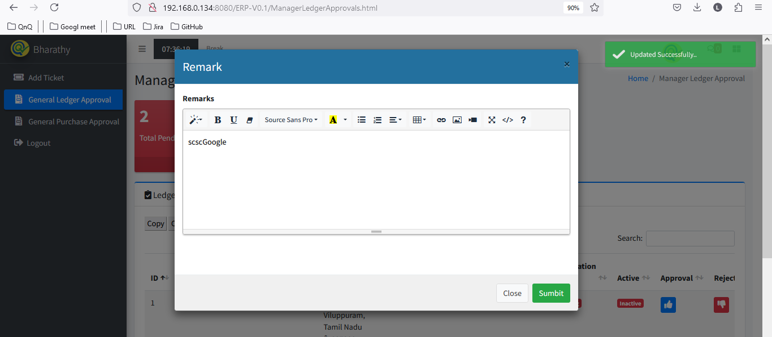

//

31. Reject pop up getting close without click close icon 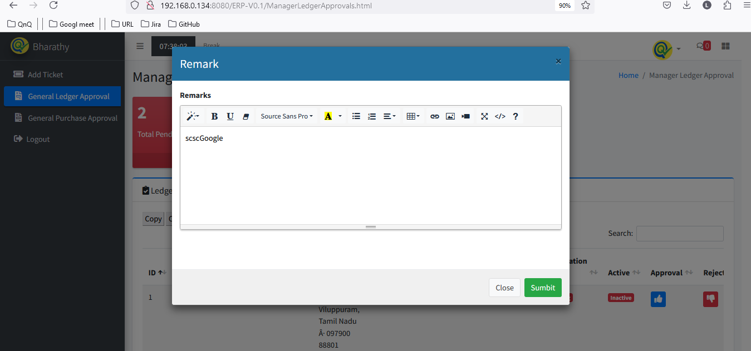 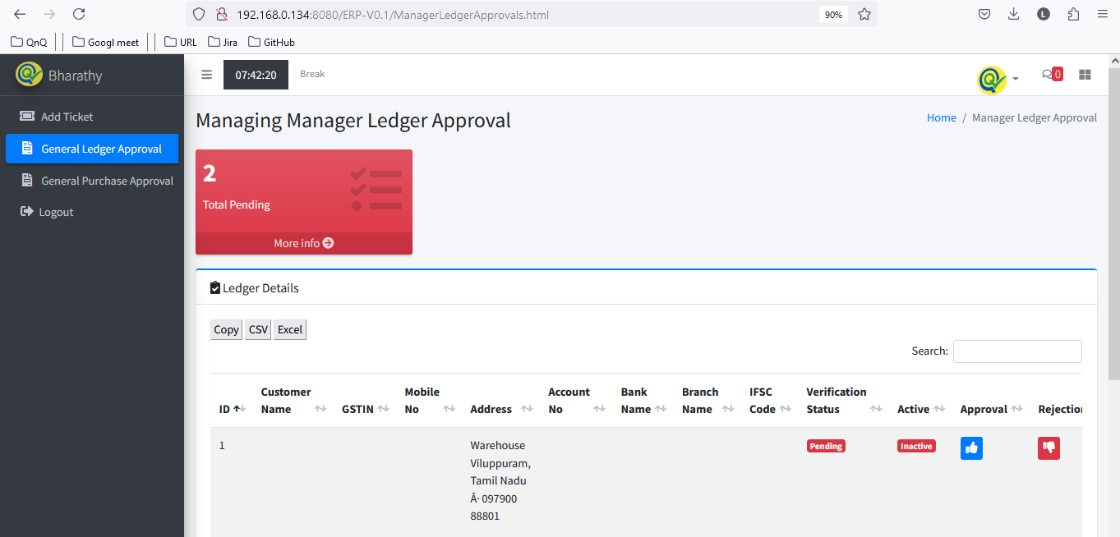

//

32. Unwanted field display while drag and drop any value in Remarks field 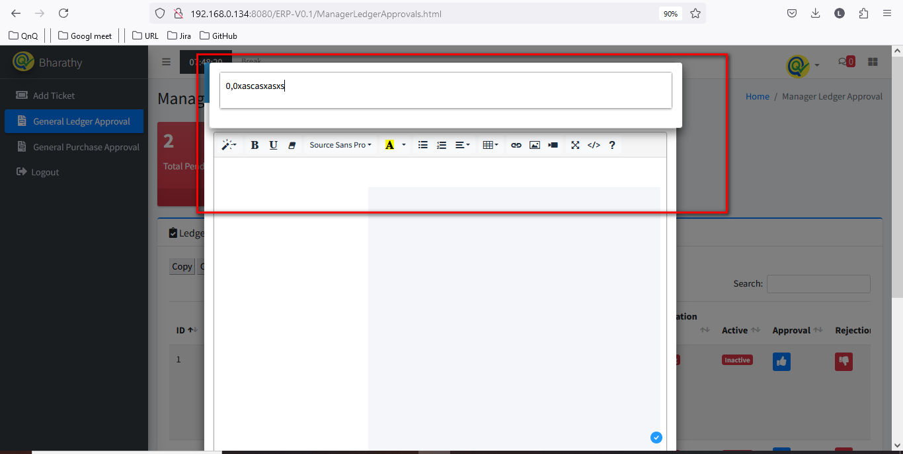

//

33. Approved record not display in Manager Ledger Approval list grid 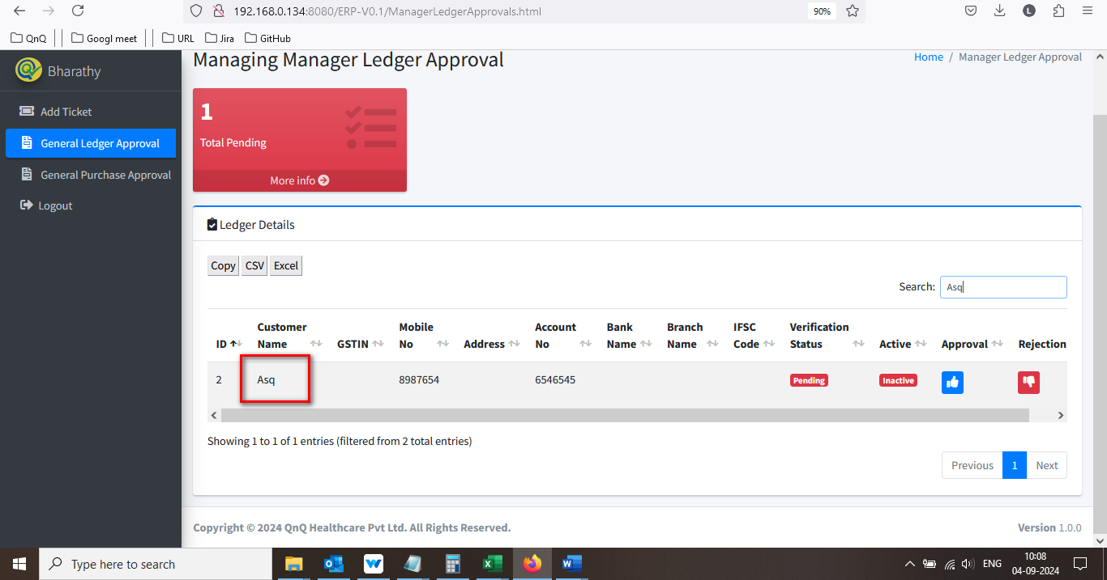 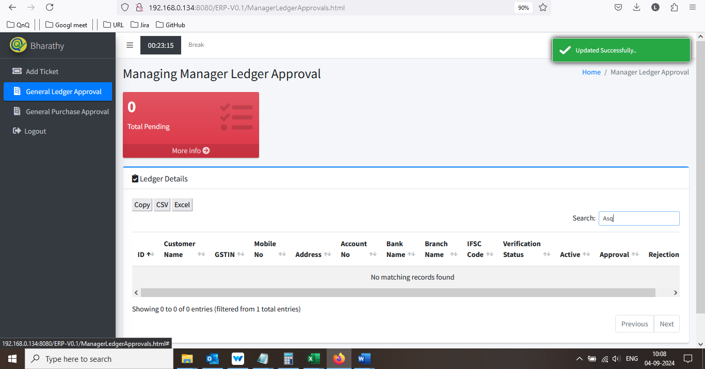

//

34. User can able to submit the rejection pop up with space value alone 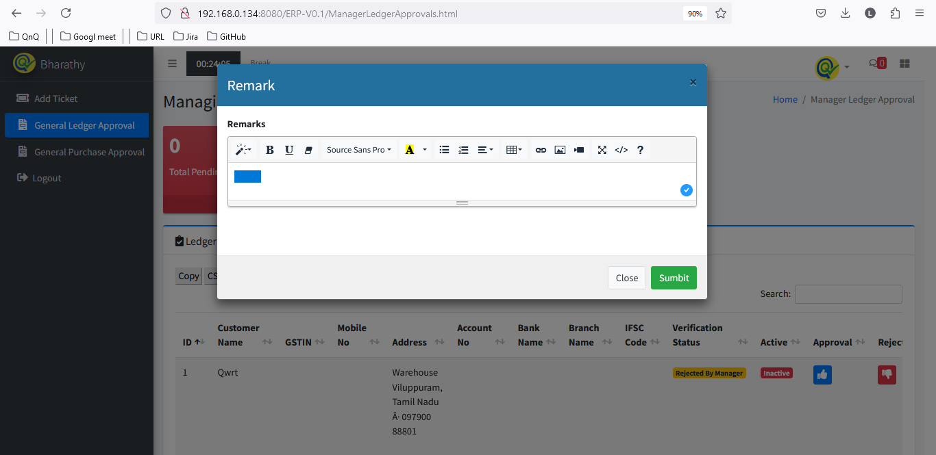 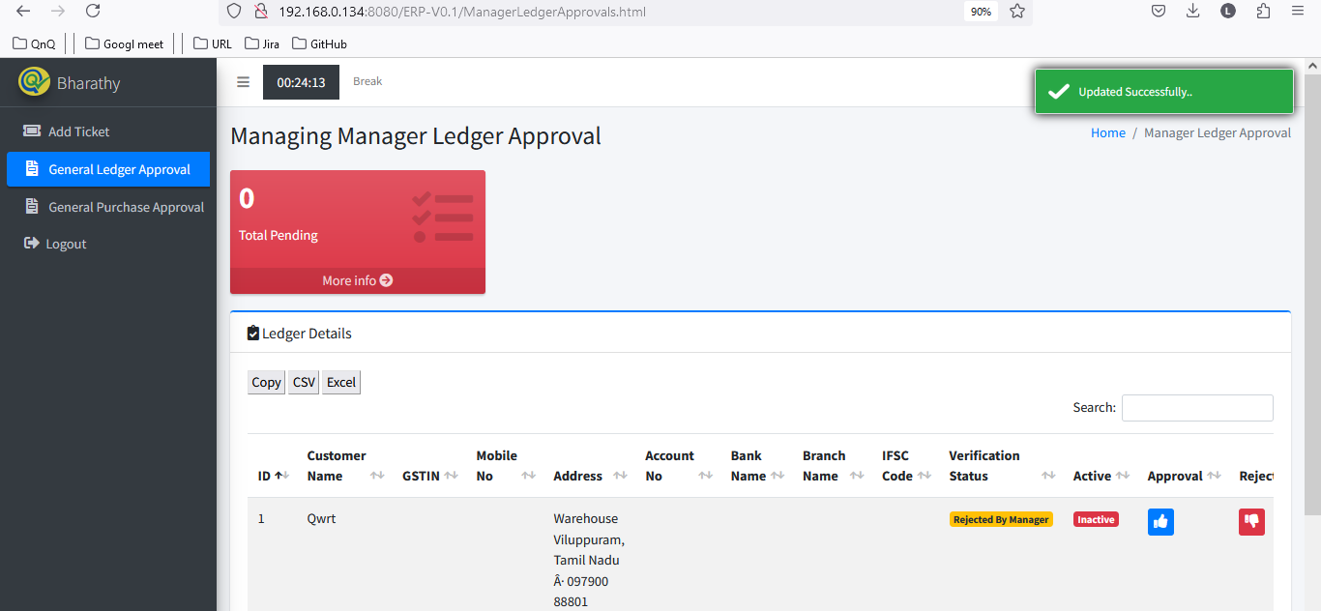

//

35. Mismatch column name display in Manager Ledger Approval list grid 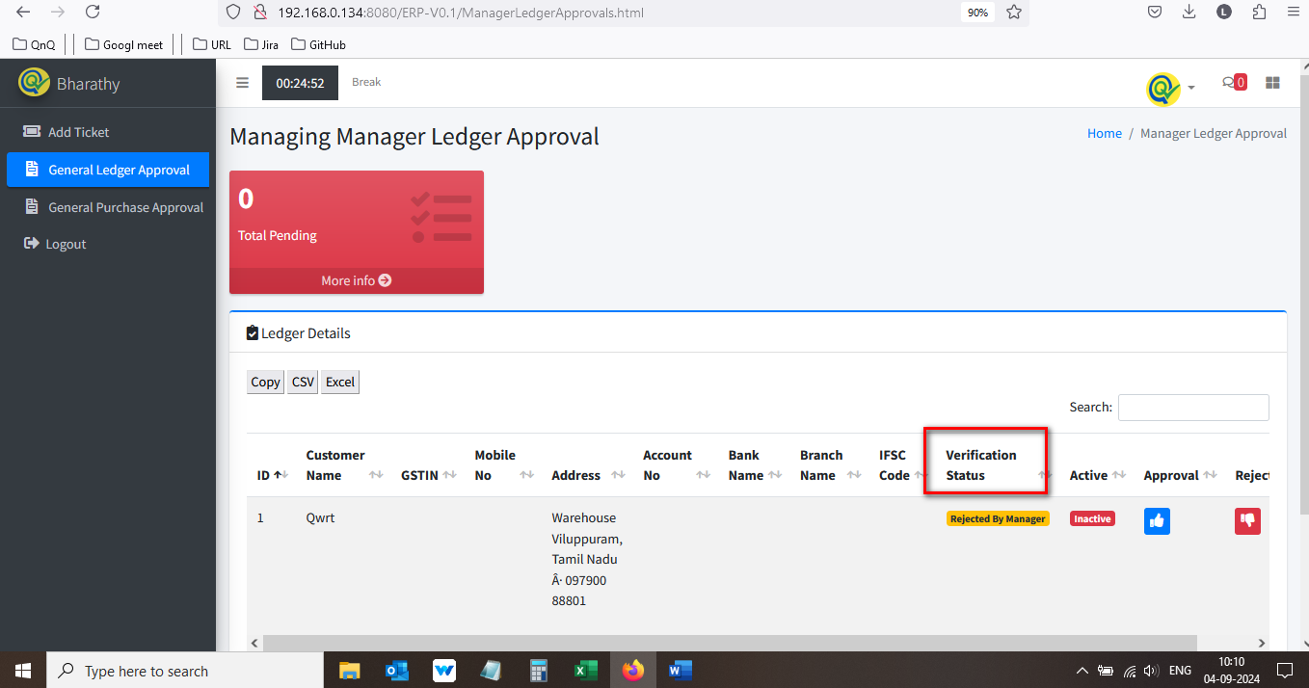

//

36. Approved success message display mismatch content 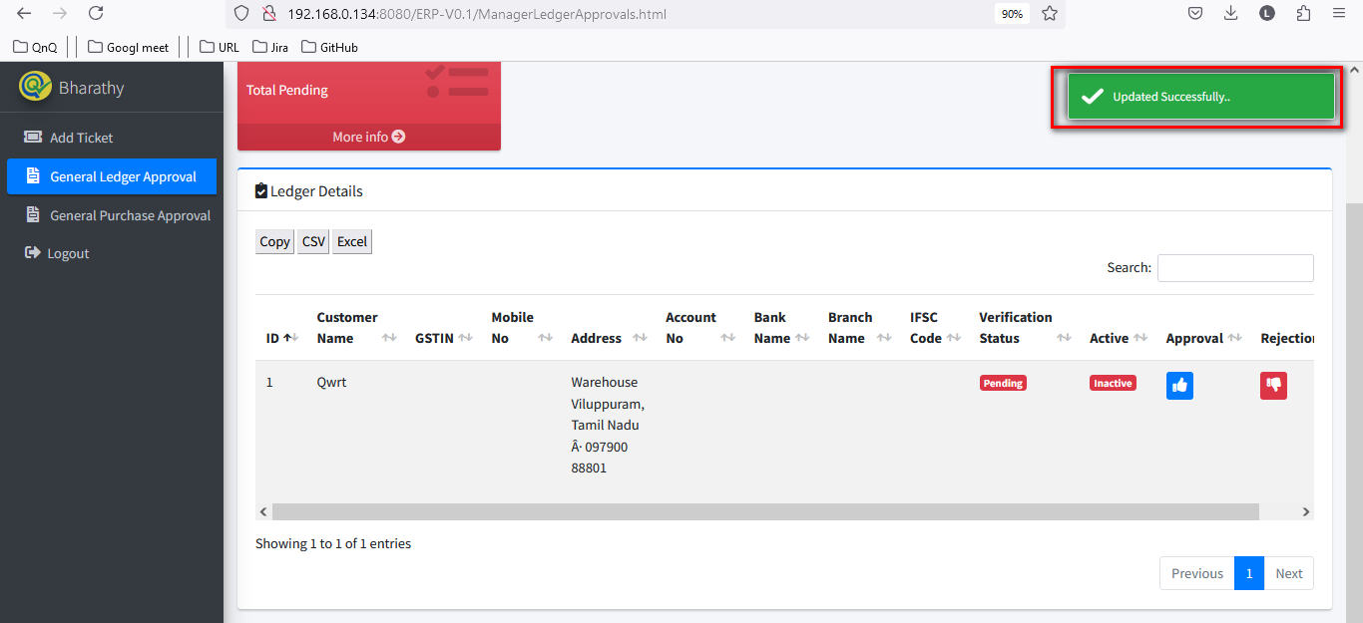

//

37. Rejected success message display mismatch content 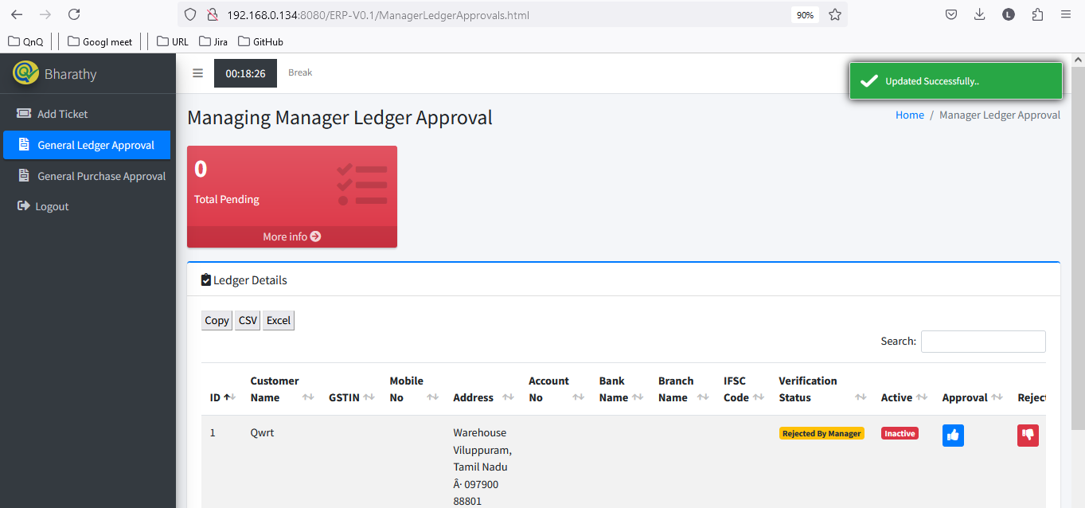

//

38. System allow to perform reject the same record for multiple time  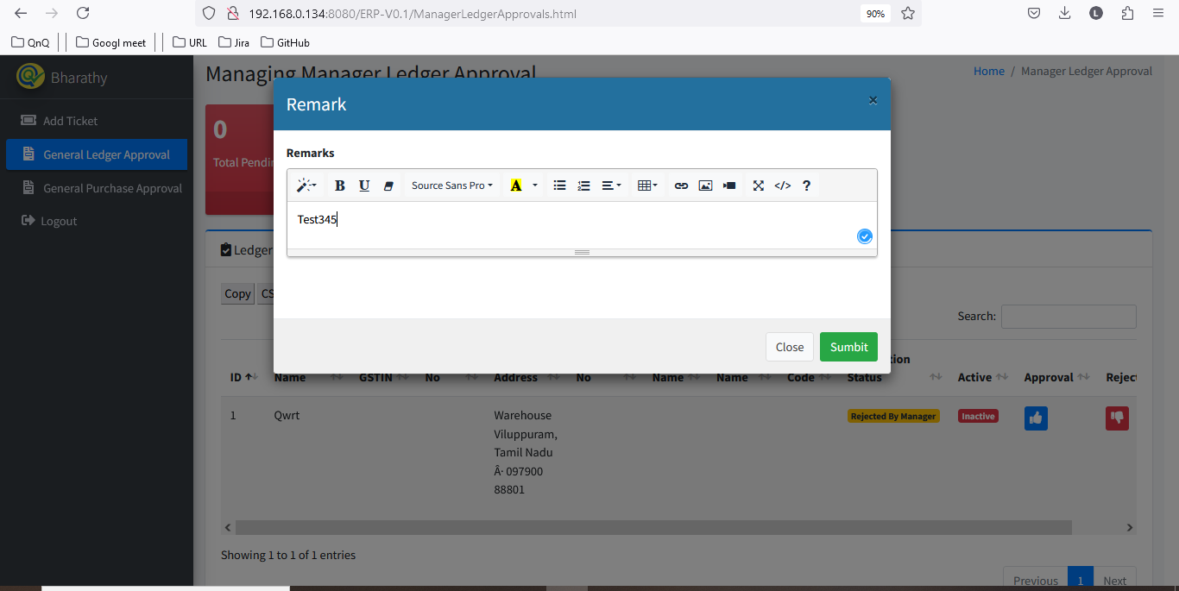 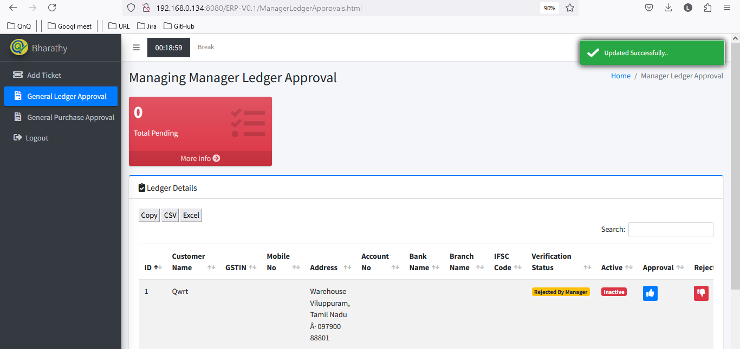

//

39. Created record not display in General Ledger master 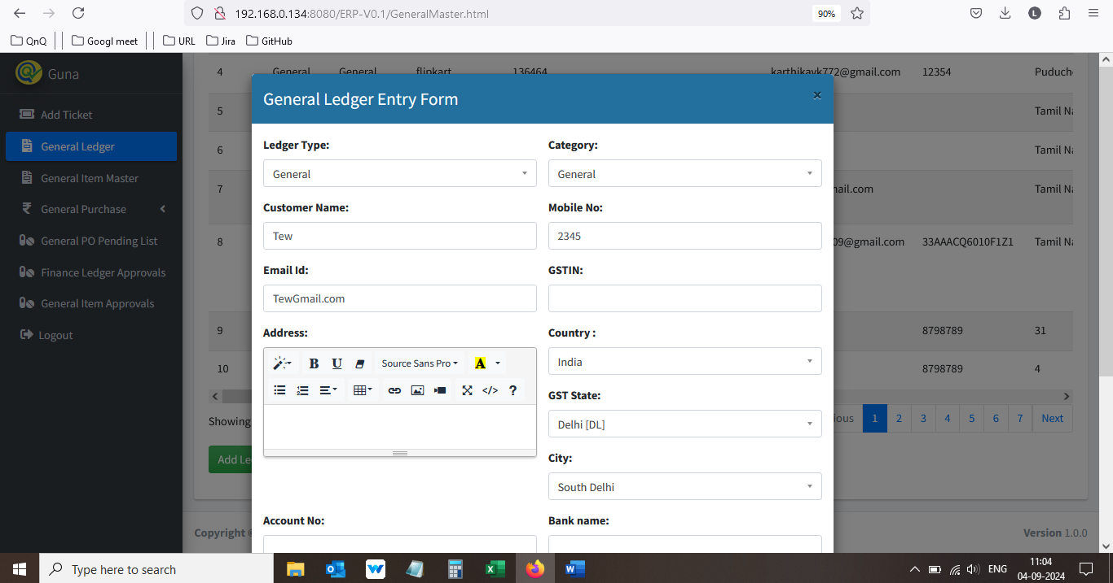 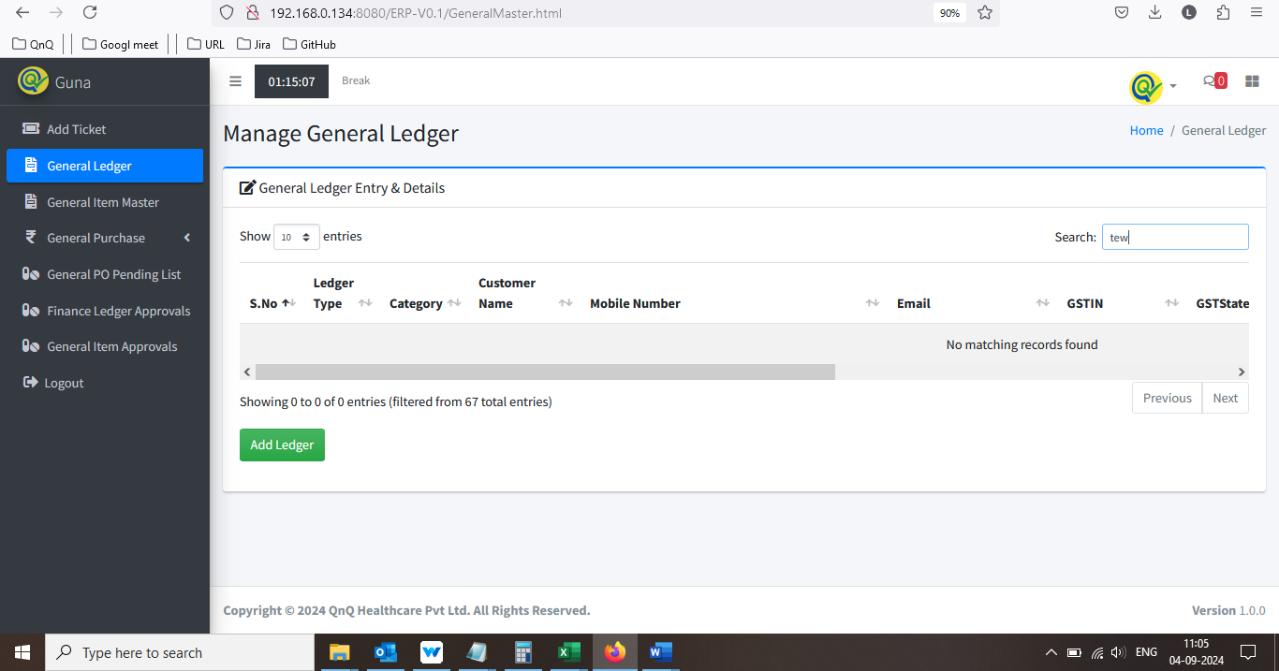

//

40. Rejected Ledger record not display in General Ledger master 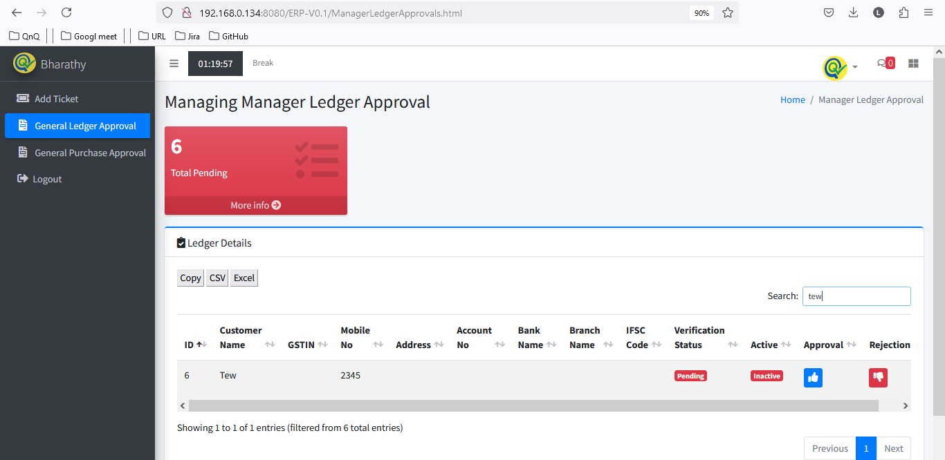 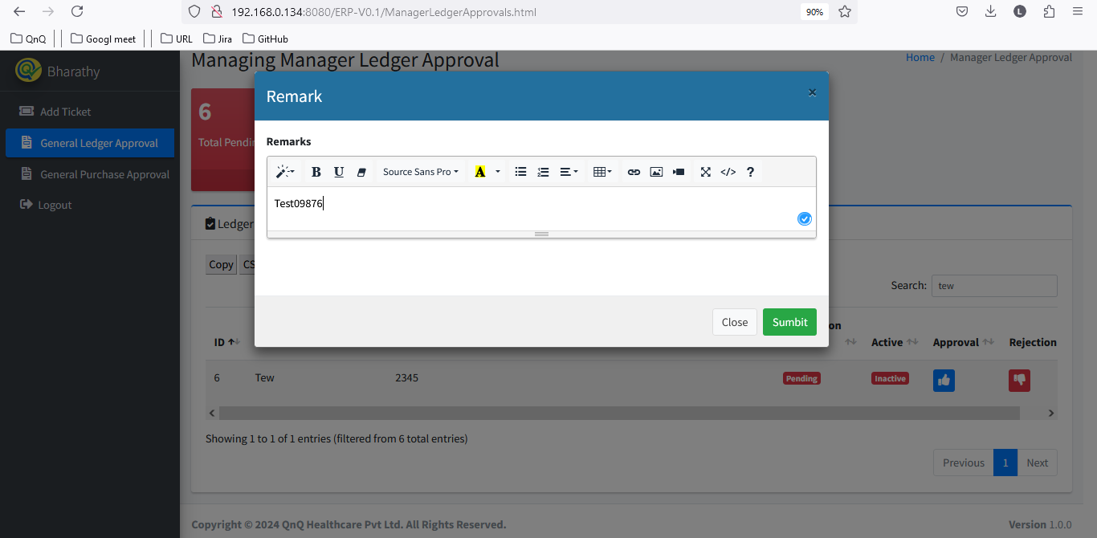 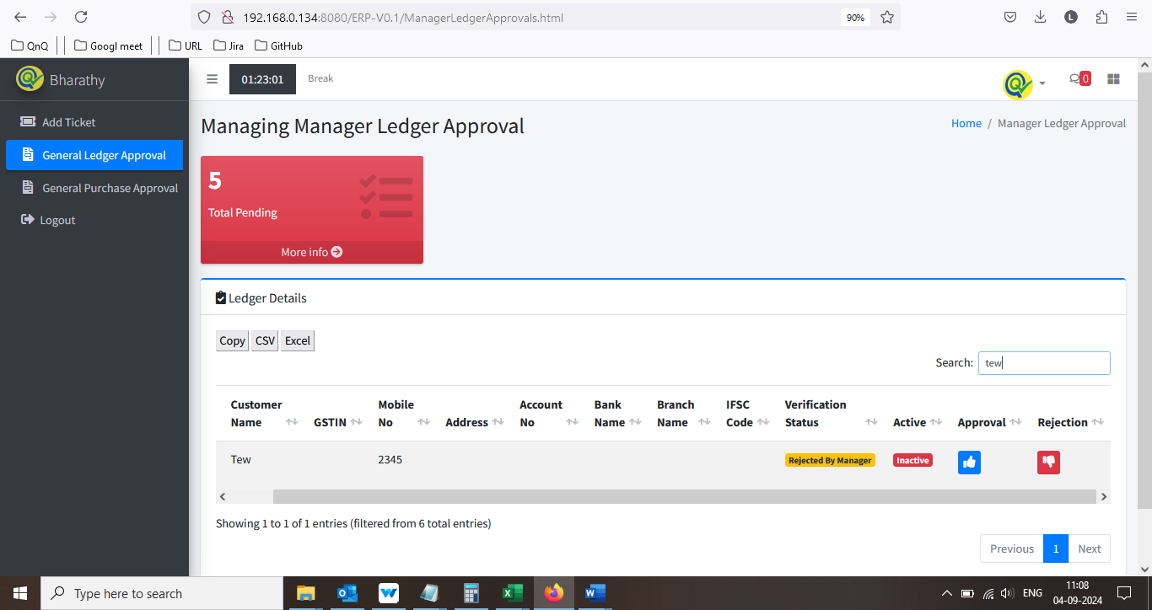 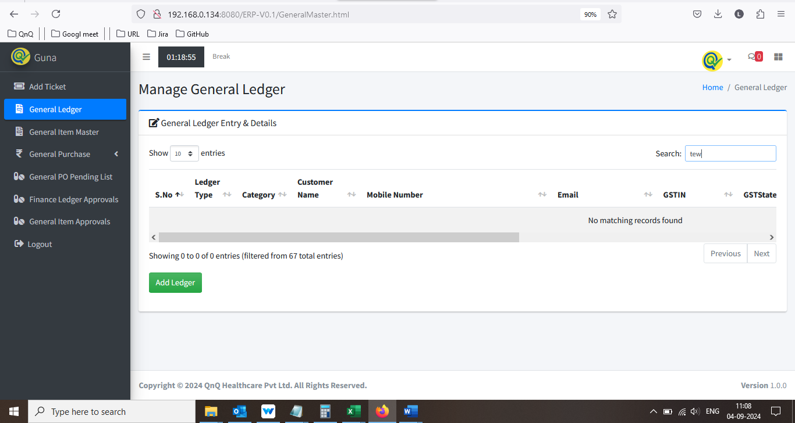

//

41. User unable to update the ledger record while reject the record in Manager Ledger approval    

//

42. Active status name as Inactive in manager Ledger approval list grid display the record, which is create in Ledger approve with active status 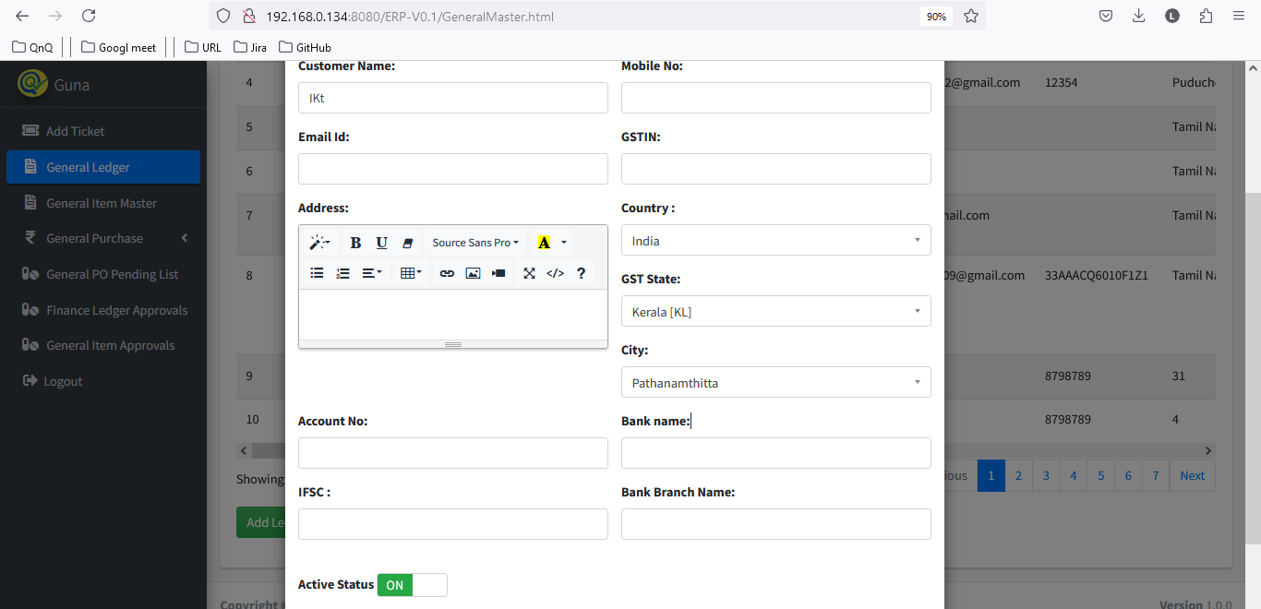 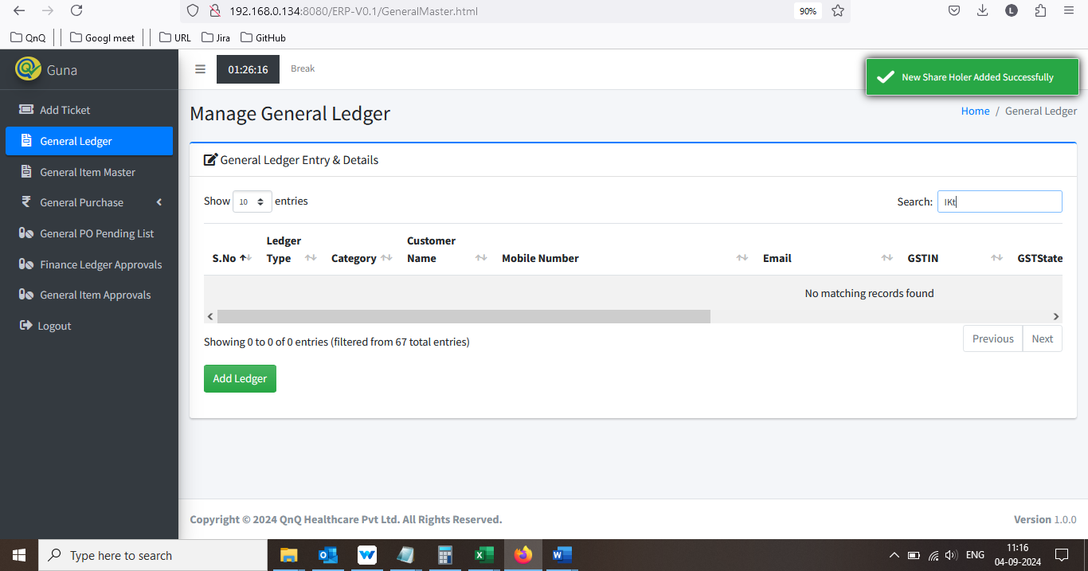 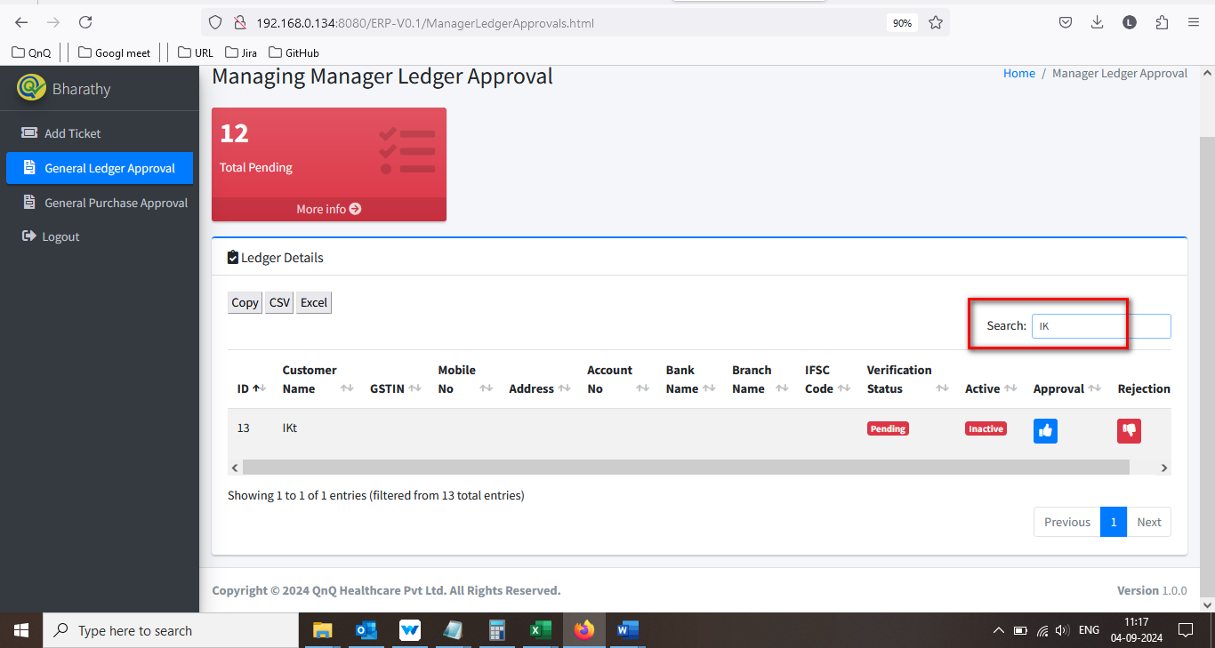

//

43. Showing count dropdown not display in in Manager Ledger approval page 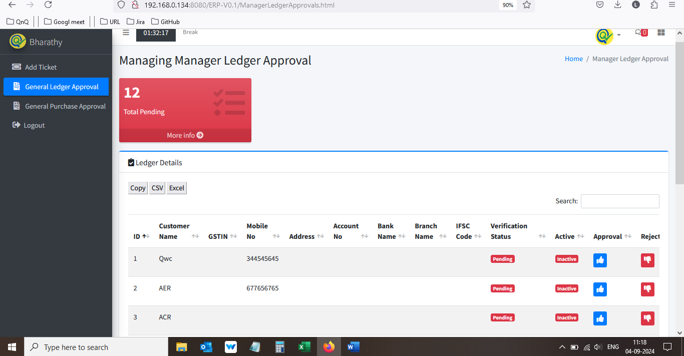

//

44. Error message display while open the Manager Ledger approval CSV file 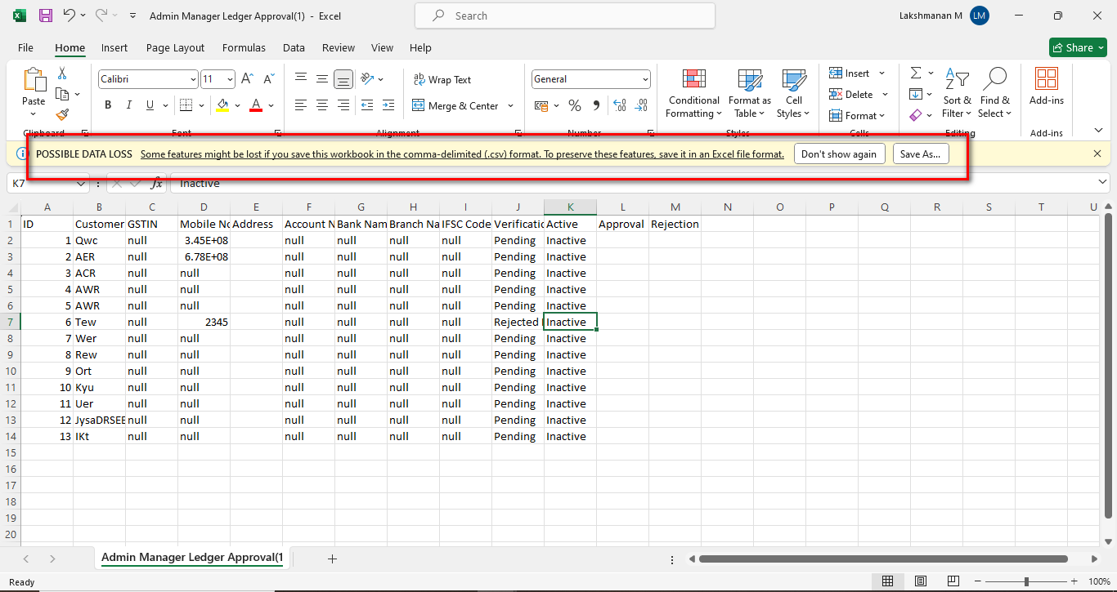

//

45. Null value display while open the Manager Ledger approval CSV file 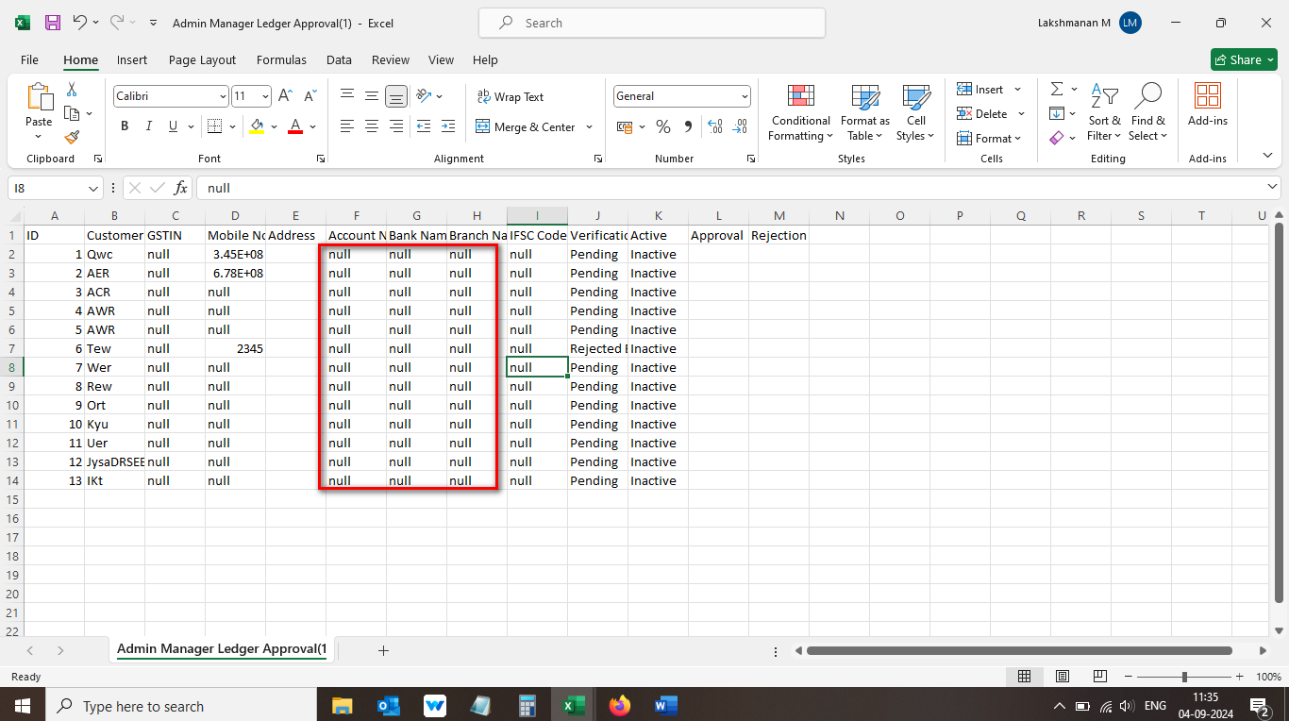

//

46. Header column not display properly in Manager Ledger approval CSV file 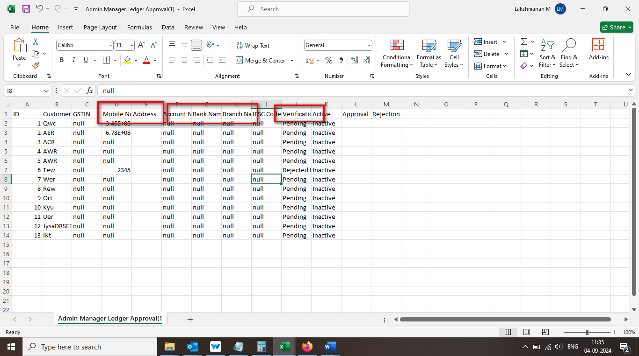

//

47. Header column display as normal column in Manager Ledger approval CSV file 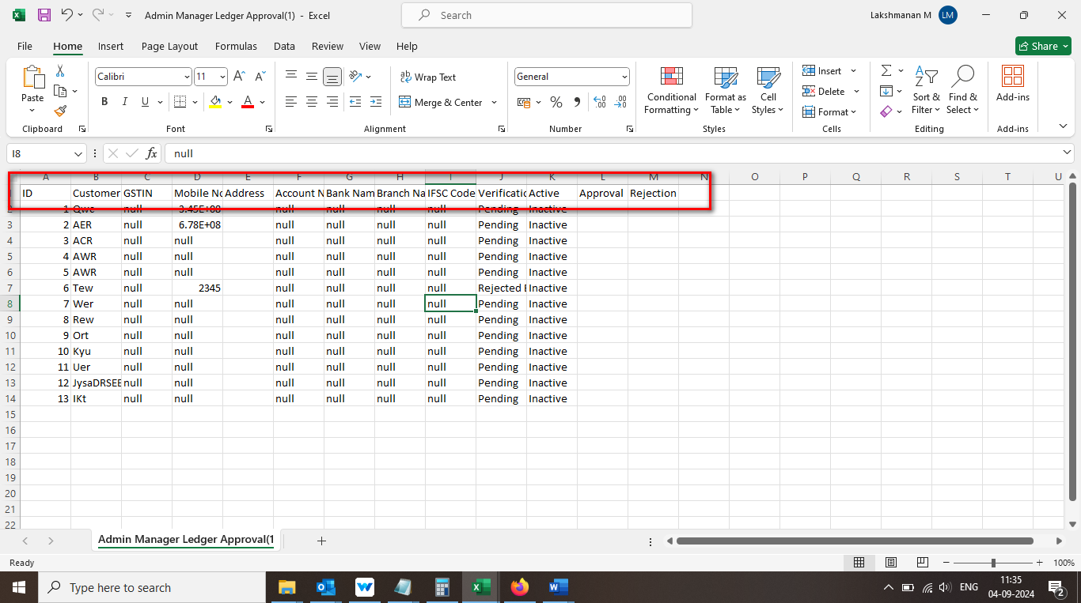

//

48. Given value not display properly in Manager Ledger approval CSV file 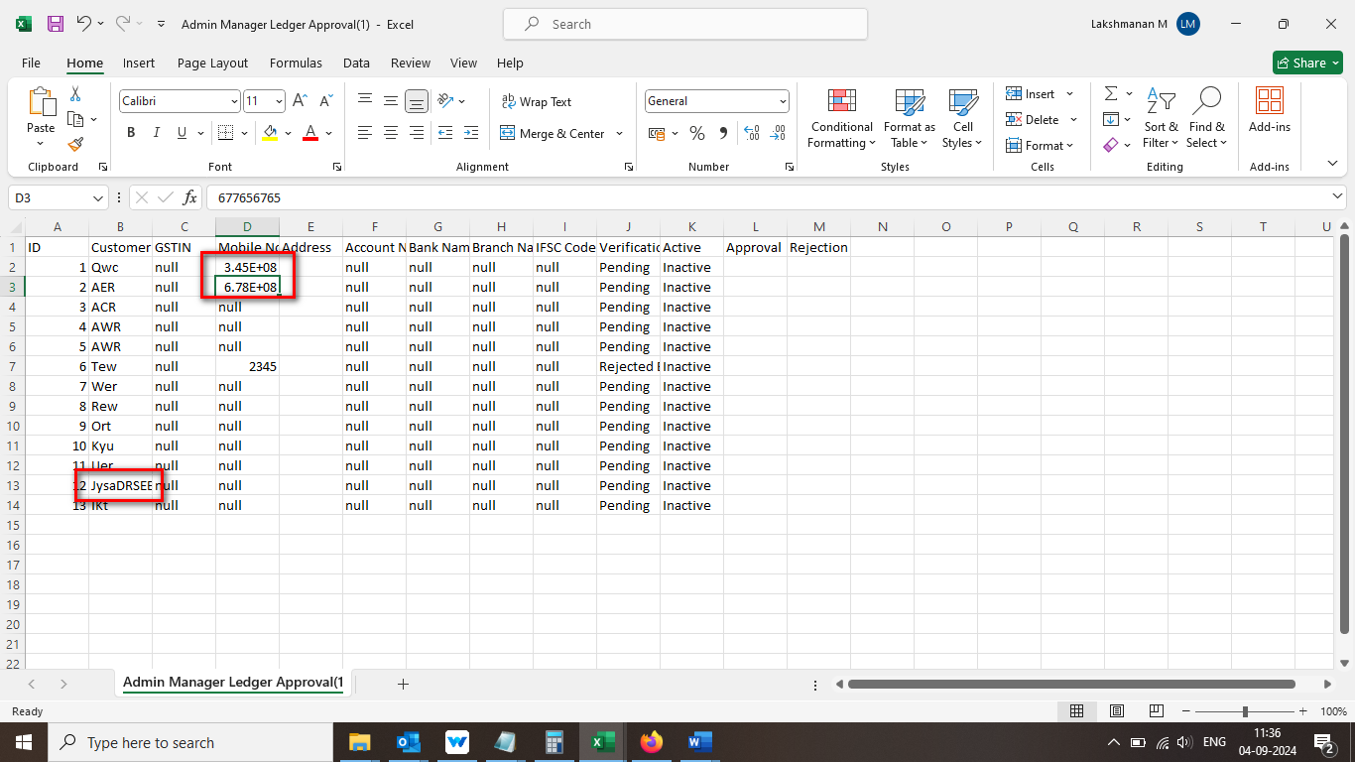

//

49. Unwanted column display in Manager Ledger approval CSV file 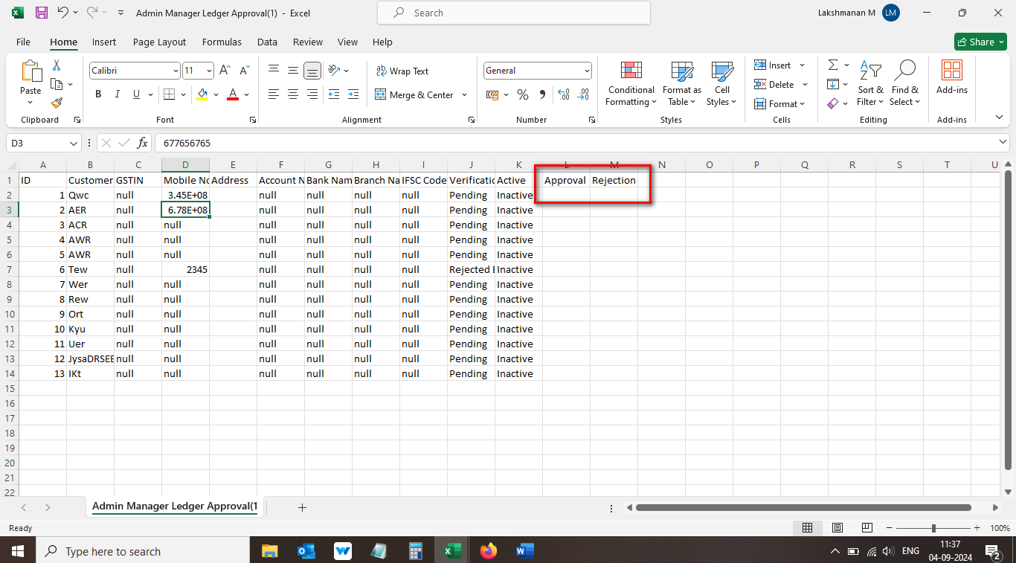

//

50. Sheet name display with number in Manager Ledger approval CSV file 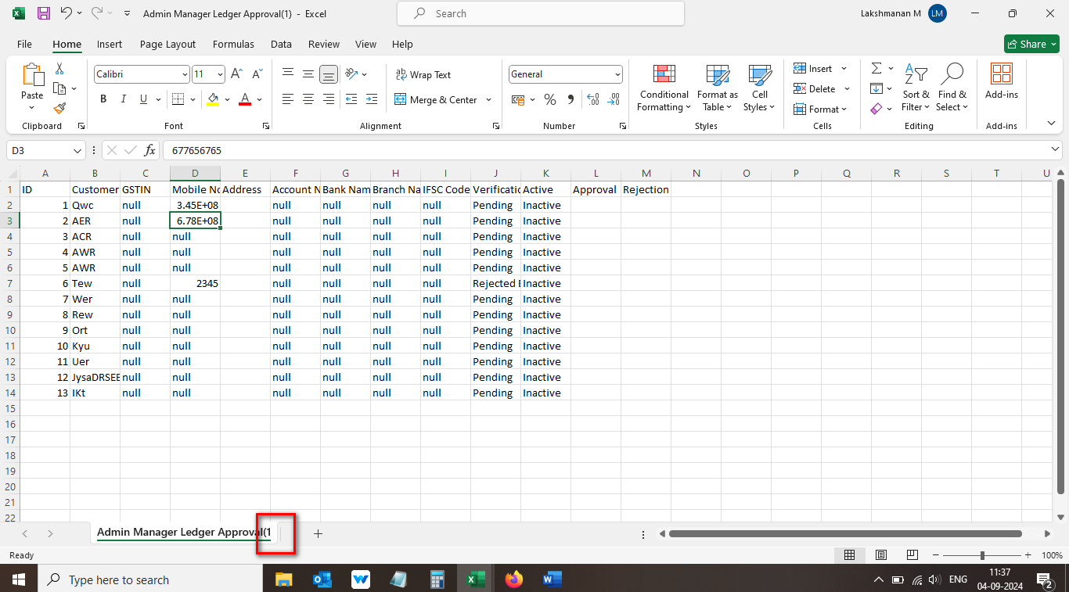

//

51.Improper alignment display in Excel sheet 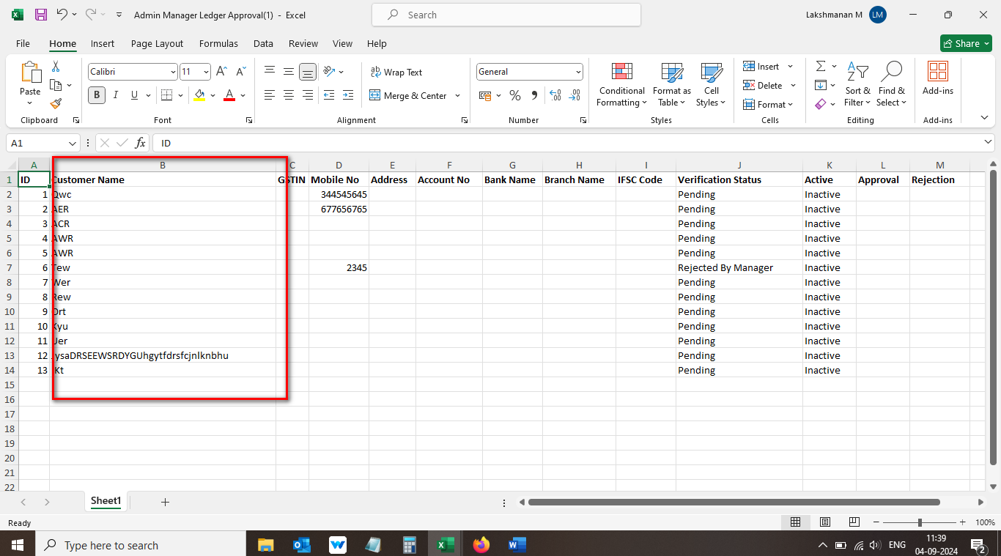

//

52. Mismatch sheet name display in Manager Ledger approval Excel file 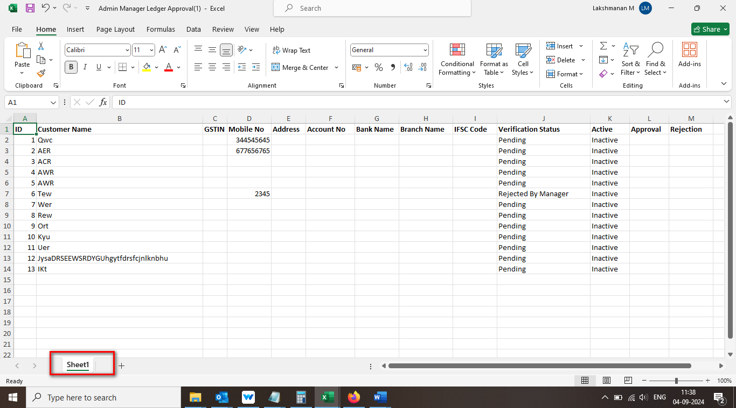

//

53.Mismatch name display for downloaded file 

